Kendriya Vidyalaya
UPPER CAMP
DEHRADUN

A Project Report
on

TRAVEL AGENCY Management System

For
AISSCE 2012 Examination
[As a part of the Informatics Practices Course (065)]

SUBMITTED BY: -
ARJUN SINGH Roll No: - 5735122
shiv singh Roll No: - 5735109
sumeet kumar tiwari Roll No: - 5735147

Under the Guidance of:
MR.Rajesh Kumar Mishra
PGT (Comp.Sc)
CERTIFICATE

This is to certify that the Project / Dissertation entitled TRAVEL AGENCY Management System is a bonafide work done by Master ARJUN SINGHof class XII-A Session 2011-12 in partial fulfillment of CBSE’s AISSCE Examination 2012 and has been carried out under my direct supervision and guidance. This report or a similar report on the topic has not been submitted for any other examination and does not form a part of any other course undergone by the candidate.

………………………… ……………………………..

Signature of Student Signature of Teacher/Guide

Name: ARJUN SINGH Name: MR. RAJESH KUMAR MISHRA
Roll No.: 5735122 Designation: PGT (Comp.Sc.)

……….…………………

Signature of Principal
Name: MR. Y.BHARDWAJ
Place: DEHRADUN
Date: -02-2012

ACKNOWLEDGEMENT
Iundertook this Project work, as the part of my XII-Informatics Practices course. I had tried to apply my best of knowledge and experience, gained during the study and class work experience. However, developing software system is generally a quite complex and time-consuming process. It requires a systematic study, insight vision and professional approach during the design and development. Moreover, the developer always feels the need, the help and good wishes of the people near you, who have considerable experience and idea.
I would like to extend my sincere thanks and gratitude to my teacher MR. RAJESH KUMAR MISHRA . I am very much thankful to our Principal MR. Y.BHARDWAJ for giving valuable time and moral support to develop this software.
I would like to take the opportunity to extend my sincere thanks and gratitude to my father SHRI RAM AUTAR, and my mother MRS. ANITA DEVI for being a source of inspiration and providing time and freedom to develop this software project.
I also feel indebted to my friends for the valuable suggestions during the project work.

ARJUN SINGH

Class XII

C O N T E N T S

1. Introduction 1
2. Objective & Scope of the Project 2
3. Theoretical Background 4
4. Problem Definition & Analysis 16
5. System Implementation 22
6.1 The Hardware used: 22
6.2 The Softwares used: 22
6. System Design & Development 23
7.2 Database Design: 24
7.3 Menu Design: 34
7.4 I/O Forms Design & Event Coding: 36
7. User Manual 150
8.1 How to install: 151
8.2 Working with Software: 152
8. References 173

1. Introduction
This software project is developed to automate the functionalities of a travel agency.The purpose of the software project is to develop the Management Information System (MIS) to automate the record keeping of vehicles, Members ,veh types and vehicles issue and receive transactions with a view to enhance the decision making of the functionaries.
A MIS mainly consists of a computerized database, a collection of inter-related tables for a particular subject or purpose, capable to produce different reports relevant to the user. An application program is tied with the database for easy access and interface to the database. Using Application program or front-end, we can store, retrieve and manage all information in proper way.
This software, being simple in design and working, does not require much of training to users, and can be used as a powerful tool for automating a TRAVEL AGENCY SYSTEM.
During coding and design of the software Project, Java NetBeans IDE, a powerful front-end tool is used for getting Graphical User Interface (GUI) based integrated platform and coding simplicity. As a back-end a powerful, open source RDBMS, My SQL is used as per requirement of the CBSE curriculum of Informatics Practices Course.

2. Objective & Scope of the Project
The objective of the software project is to develop a computerized MIS to automate the functions of a TRAVEL AGENCY SYSTEM .This software project is also aimed to enhance the current record keeping system, which will help managers to retrieve the up-to-date information at right time in right shape.
The proposed software system is expected to do the following functionality-
- To provide a user friendly, Graphical User Interface (GUI) based integrated and centralized environment for MIS activities.
- The proposed system should maintain all the records and transactions, and should generate the required reports and information when required.
- To provide graphical and user-friendly interface to interact with a centralized database based on client-server architecture.
- To identify the critical operation procedure and possibilities of simplification using modern IT tools and practices.
In its current scope, the software enables user to retrieve and update the information from centralized database designed with MySQL . This software does not require much training time of the users due to limited functionality and simplicity.
During the development of TRAVEL AGENCY SYSTEM project, Java NetBeans IDE, a powerful, open source event-driven form-based development environment is used for modular design and future expandability of the system.
Despite of the best effort of the developer, the following limitations and functional boundaries are visible, which limits the scope of this application software.
- This software can store records and produce reports in pre-designed format in soft copy. There is no facility yet to produce customized reports. Only specified reports are covered.
- There is no provision to calculate fine or penalty etc. for defaulter members; however it can be developed easily with the help of adding modules.
- Some application area like accounting of vehicles and fines etc. are not implemented in the project. It facilitates manager to record and update only transaction record.
So far as future scope of the project is concerned, firstly it is open to any modular expansion i.e. other modules or functions can be designed and embedded to handle the user need in future. Any part of the software and reports can be modified independently without much effort.

3. Theoretical Background

3.1 What is Database?

Introduction and Concepts:
A database is a collection of information related to a particular subject or purpose, such as tracking customer orders or maintaining a music collection. Using any RDBMS application software like MS SQL Server, MySQL, Oracle, Sybase etc, you can manage all your information from a single database file. Within the file, divide your data into separate storage containers called tables. You may and retrieve the data using queries.
A table is a collection of data about a specific topic, such as products or suppliers. Using a separate table for each topic means you can store that data only once, which makes your database more efficient and reduces data-entry errors. Table organises data into columns (called fields) and rows (called records).
A Primary key is one or more fields whose value or values uniquely identify each record in a table. In a relationship, a primary key is used to refer to specific record in one table from another table. A primary key is called foreign key when it is referred to from another table.

To find and retrieve just the data that meets conditions you specify, including data from multiple tables, create a query. A query can also update or delete multiple records at the same time, and perform built-in or custom calculations on your data.
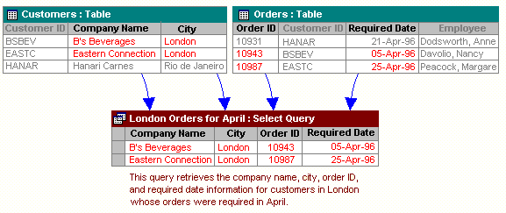

Role of RDBMS Application Program:
A computer database works as a electronic filing system, which has a large number of ways of cross-referencing, and this allows the user many different ways in which to re-organize and retrieve data. A database can handle business inventory, accounting and filing and use the information in its files to prepare summaries, estimates and other reports. The management of data in a database system is done by means of a general-purpose software package called a Database Management System (DBMS). Some commercially available DBMS are MS SQL Server, MS ACCESS, INGRES, ORACLE, and Sybase. A database management system, therefore, is a combination of hardware and software that can be used to set up and monitor a database, and can manage the updating and retrieval of database that has been stored in it. Most of the database management systems have the following capabilities:
- Creating of a table, addition, deletion, modification of records.
- Retrieving data collectively or selectively.
- The data stored can be sorted or indexed at the user's discretion and direction.
- Various reports can be produced from the system. These may be either standardized report or that may be specifically generated according to specific user definition.
- Mathematical functions can be performed and the data stored in the database can be manipulated with these functions to perform the desired calculations.
- To maintain data integrity and database use.
The DBMS interprets and processes users' requests to retrieve information from a database. In most cases, a query request will have to penetrate several layers of software in the DBMS and operating system before the physical database can be accessed. The DBMS responds to a query by invoking the appropriate subprograms, each of which performs its special function to interpret the query, or to locate the desired data in the database and present it in the desired order.

3.2 What is My SQL ? 
The management of data in a database system is done by means of a general-purpose software package called a Database Management System (DBMS). Some commercially available RDBMS are MS SQL Server, MS ACCESS, INGRES, ORACLE, and Sybase.
MySQL, the most popular Open Source SQL database management system, is developed, distributed, and supported by Oracle Corporation. MySQL is named after co-founder Monty Widenius's daughter, My. The name of the MySQL Dolphin (our logo) is “Sakila,”.
- MySQL is a database management system.
A database is a structured collection of data. It may be anything from a simple shopping list to a picture gallery or the vast amounts of information in a corporate network. To add, access, and process data stored in a computer database, you need a database management system such as MySQL Server. Since computers are very good at handling large amounts of data, database management systems play a central role in computing, as standalone utilities, or as parts of other applications.
- MySQL is based on SQL.
A relational database stores data in separate tables rather than putting all the data in one big storeroom. This adds speed and flexibility. The SQL part of “MySQL” stands for “Structured Query Language.” SQL is the most common standardized language used to access databases and is defined by the ANSI/ISO SQL Standard. The SQL standard has been evolving since 1986 and several versions exist. In this manual, “SQL-92” refers to the standard released in 1992, “SQL:1999” refers to the standard released in 1999, and “SQL:2003” refers to the current version of the standard.
- MySQL software is Open Source.
Open Source means that it is possible for anyone to use and modify the software. Anybody can download the MySQL software from the Internet and use it without paying anything. If you wish, you may study the source code and change it to suit your needs. The MySQL software uses the GPL (GNU General Public License),
- The MySQL Database Server is very fast, reliable, and easy to use.
If that is what you are looking for, you should give it a try. MySQL Server also has a practical set of features developed in close cooperation with our users. You can find a performance comparison of MySQL Server with other database managers on our benchmark page. MySQL Server was originally developed to handle large databases much faster than existing solutions and has been successfully used in highly demanding production environments for several years. Although under constant development, MySQL Server today offers a rich and useful set of functions. Its connectivity, speed, and security make MySQL Server highly suited for accessing databases on the Internet.
- MySQL Server works in client/server or embedded systems.
The MySQL Database Software is a client/server system that consists of a multi-threaded SQL server that supports different backends, several different client programs and libraries, administrative tools, and a wide range of application programming interfaces (APIs).

The Main Features of MySQL
- Written in C and C++.
- Works on many different platforms.
- Uses multi-layered server design with independent modules.
- Provides transactional and nontransactional storage engines.
- Designed to make it relatively easy to add other storage engines. This is useful if you want to provide an SQL interface for an in-house database.
- Uses a very fast thread-based memory allocation system.
- Executes very fast joins using an optimized nested-loop join.
- Implements SQL functions using a highly optimized class library that should be as fast as possible. Usually there is no memory allocation at all after query initialization.
- Provides the server as a separate program for use in a client/server networked environment, and as a library that can be embedded (linked) into standalone applications. Such applications can be used in isolation or in environments where no network is available.
- Password security by encryption of all password traffic when you connect to a server.
- Support for large databases. We use MySQL Server with databases that contain 50 million records. We also know of users who use MySQL Server with 200,000 tables and about 5,000,000,000 rows.
- MySQL client programs can be written in many languages. A client library written in C is available for clients written in C or C++, or for any language that provides C bindings.
- APIs for C, C++, Eiffel, Java, Perl, PHP, Python, Ruby, and Tcl are available, enabling MySQL clients to be written in many languages.
- The Connector/ODBC (MyODBC) interface provides MySQL support for client programs that use ODBC (Open Database Connectivity) connections.
- The Connector/J interface provides MySQL support for Java client programs that use JDBC connections. Clients can be run on Windows or Unix. Connector/J source is available.

3.3 What is NetBeans IDE ?
NetBeans started as a student project (originally called Xelfi) in the Czech Republic in 1996. The goal was to write a Delphi-like Java IDE in Java. Xelfi was the first Java IDE (Integrated Development Environment) written in Java, with its first pre-releases in 1997. Xelfi was a fun project to work on, especially since Java IDE space was uncharted territory at that time. The project attracted enough interest that these students, once they graduated, decided that they could market it as a commercial product. Soliciting resources from friends and relatives for a web space, they formed a company around it.
Soon after, they were contacted by Roman Stanek, an entrepreneur who had already been involved in several startups in the Czech Republic. He was looking for a good idea to invest in, and discovered Xelfi. He met with the founders; they hit it off, and a business was born.
In the spring of 1999, NetBeans DeveloperX2 was released, supporting Swing. The performance improvements that came in JDK 1.3, released in the fall of 1999, made NetBeans a viable choice for development tools. By the summer of 1999, the team was hard at work re-architecting DeveloperX2 into the more modular NetBeans that forms the basis of the software today.
Something else was afoot in the summer of 1999: Sun Microsystems wanted better Java development tools, and had become interested in NetBeans. It was a dream come true for the NetBeans team: NetBeans would become the flagship tool set of the maker of Java itself! By the Fall, with the next generation of NetBeans Developer in beta, a deal was struck. Sun Microsystems had also acquired another tools company, During the acqusition, the young developers who had been involved in open-source projects for most of their programming careers, mentioned the idea of open-sourcing NetBeans. Fast forward to less than six months later, the decision was made that NetBeans would be open sourced. While Sun had contributed considerable amounts of code to open source projects over the years, this was Sun's first sponsored open source project, one in which Sun would be paying for the site and handling the infrastructure.

Features of NetBeans
A free, open-source Integrated Development Environment for software developers. You get all the tools you need to create professional desktop, enterprise, web, and mobile applications with the Java platform, as well as C/C++, PHP, JavaScript, Groovy, and Ruby.
NetBeans IDE 6.9 introduces the JavaFX Composer, support for JavaFX SDK 1.3, OSGi interoperability, support for the PHP Zend framework and Ruby on Rails 3.0, and more.

4. Problem Definition & Analysis
The hardest part of building a software system is deciding precisely what to build. No other part of the conceptual work is so difficult as establishing the detailed technical requirement. Defining and applying good, complete requirements are hard to work, and success in this endeavor has eluded many of us. Yet, we continue to make progress.
Problem definition describes the What of a system, not How . The quality of a software product is only as good as the process that creates it. Problem definition is one of the most crucial steps in this creation process. Without defining a problem, developers do not know what to build, customers do not know what to expect, and there is no way to validate that the built system satisfies the requirement.
Problem definition and Analysis is the activity that encompasses learning about the problem to be solved, understanding the needs of customer and users, trying to find out who the user really is, and understanding all the constraints on the solution. It includes all activities related to the following:
- Identification and documentation of customer’s or user’s needs.
- Creation of a document that describes the external behavior and the association constraints that will satisfies those needs.
- Analysis and validation of the requirements documents to ensure consistency, completeness, and feasibility
- Evolution of needs.
After the analysis of the functioning of a travel agency system, the proposed System is expected to do the following: -
- To provide a user friendly, Graphical User Interface (GUI) based integrated and centralized environment for computerized travel agency system.
- The proposed system should maintain all the records and transactions, and should generate the required reports and information when required.
- To provide efficient and secured Information storage, flow and retrieval system, ensuring the integrity and validity of records.
- To provide graphical and user-friendly interface to interact with a centralized database based on client-server architecture.
- To identify the critical operation procedure and possibilities of simplification using modern IT tools and practices.

5. System Implementation

5.1 The Hardware used:

While developing the system, the used hardware are:
PC with Pentium IV processor or sometimes, PC with Celeron (1.7 GHz) processor having 256 MB RAM, SVGA and other required devices.

5.2 The Softwares used:
- Microsoft Windows® XP as Operating System.
- Java NetBeans 6.9 as Front-end Development environment.
- MySQL as Back-end Sever with Database for Testing.
- MS-Word 2000 for documentation.

6. System Design & Development

6.1 Database Design:
An important aspect of system design is the design of data storage structure. To begin with a logical model of data structure is developed first. A database is a container object which contains tables, queries, reports and data validation policies enforcement rules or contraints etc. A logical data often represented as a records are kept in different tables after reducing anomalies and redundancies. The goodness of data base design lies in the table structure and its relationship.
This software project maintains a database named travel agency which contains the following tables.

Table Design:
The database of travel agency System contains 5 tables. The tables are normalized to minimize the redundancies of data and enforcing the validation rules of the organization. Most of the tables are designed to store master records. The tables and their structure are given below.

Table: Member
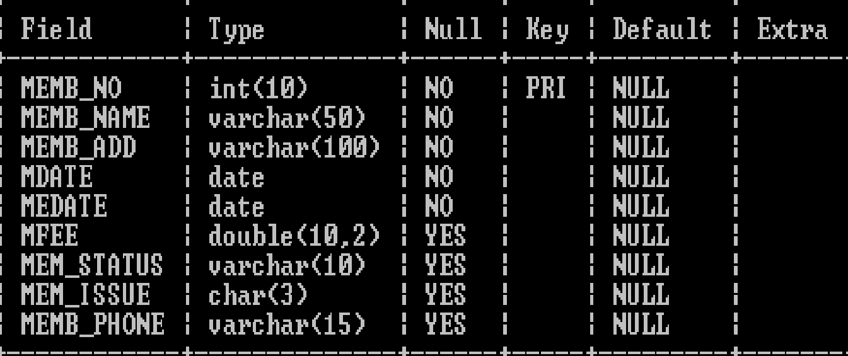
Table: veh
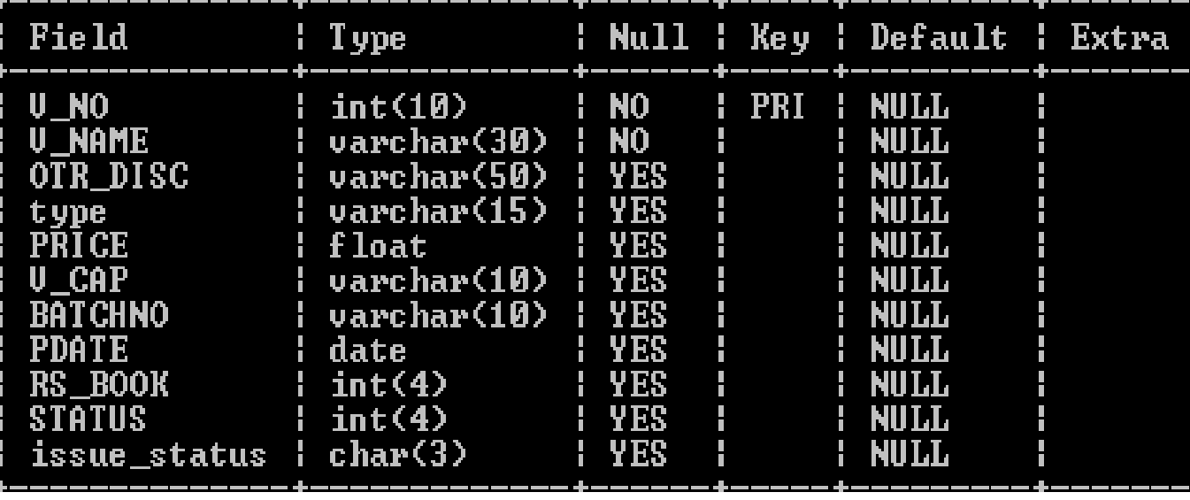
Table:Members

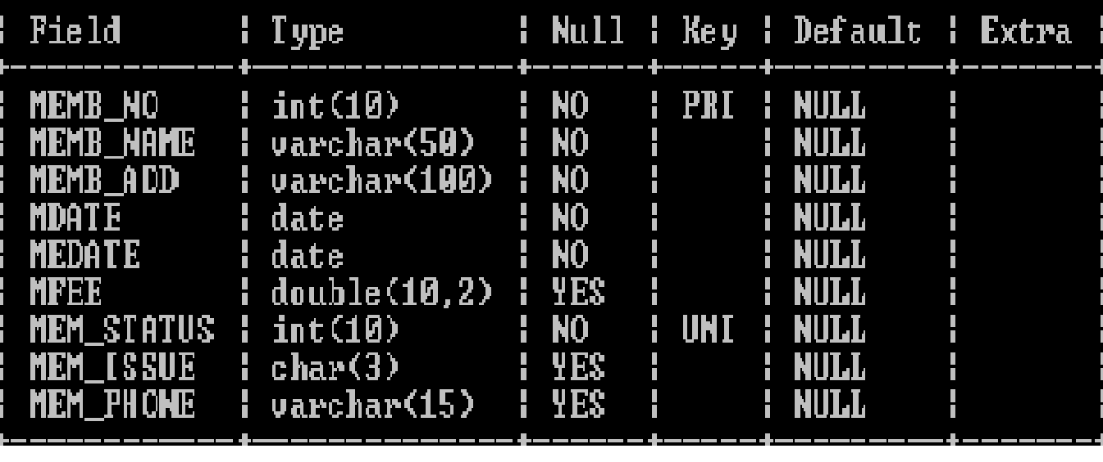
Table: MIssue
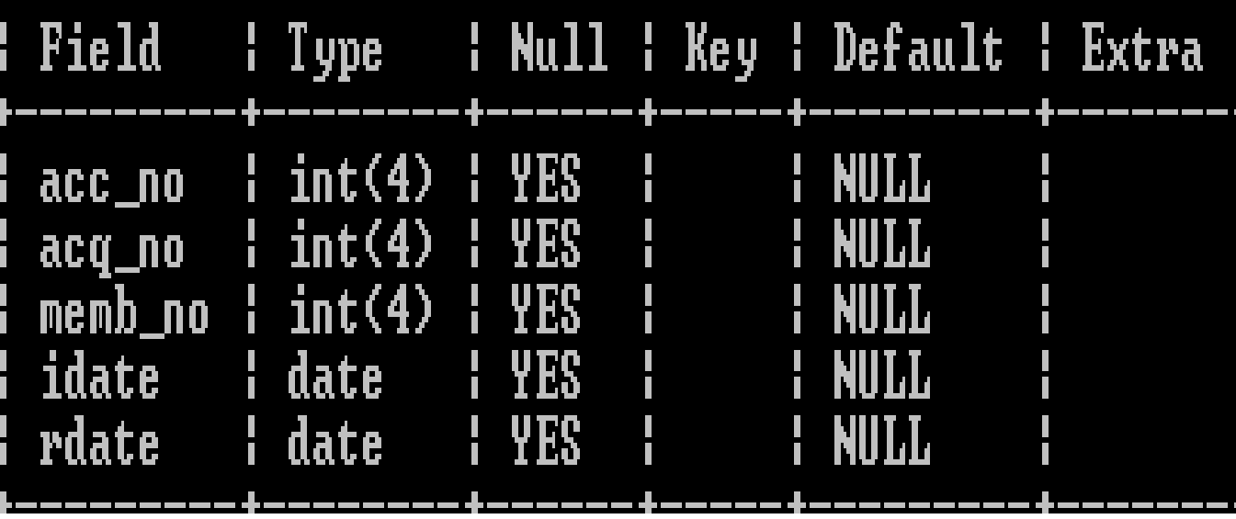
Table: TIssue
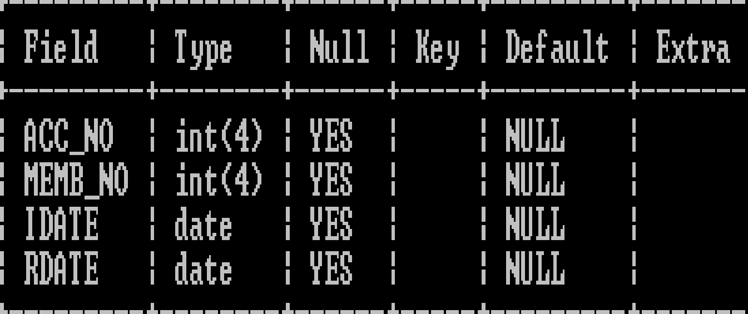

6.2 Menu Design:
JSS Infoware gateway comprises the following options, organized in a user friendly way. The menu system divided in Menu Bars, each having a pull down menus containing options for a specific task.
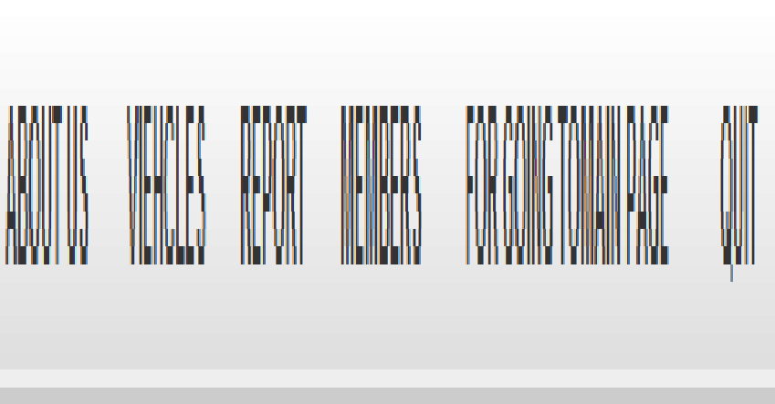

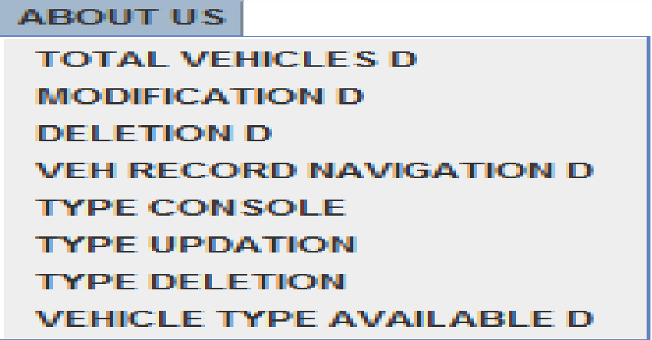
TOTAL VEHICLES | TO SEE THE VEH CURRENTLY IN TRAVEL AGENCY
MODIFICATION | TO DO MODIFICATION WITH THE RECORDS OF VEHICLES
DELETION | TO DODELETION WITH THE RECORDS OF VEHICLES
VEH REC NAVIGATION | TO SEE THE VEH CURRENTLY IN TRAVEL AGENCY ,STEP BY STEP
TYPE CONSOLE | TO INSERT THE COMPANY OF WHICH THE NEW VEHICLE IS
TYPE MODIFICATION | TO DO MODIFICATION WITH THE RECORDS OF COMPANY
TYPE DELETION | TO DODELETION WITH THE RECORDS OF COMPANY
VEH TYPE AVAILABLE | TO SEE THE COMPANY VEH CURRENTLY IN TRAVEL AGENCY

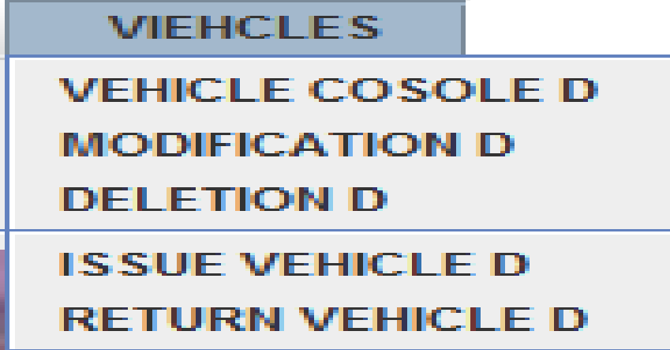

VEHICLE CONSOLE | TO INSERT THE NEW VEH RECORD
MODIFICATION | TO DO MODIFICATION WITH THE RECORDS OF VEHICLES
DELETION | TO DODELETION WITH THE RECORDS OF VEHICLES
ISSUE VEHICLE | TO BOOK/ISSUE VEH FROM AGENCY
RETURN VEHICLE | TO RETURN VEH TO AGENCY

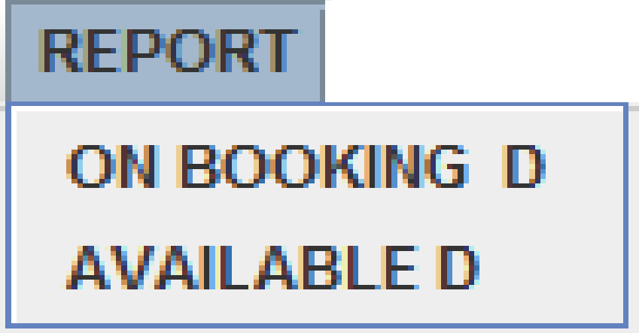

ON BOOKING | TO SEE THE VEHICLES ON BOOK
AVALABLE | TO SEE THE VEHICLES AVAILABLE

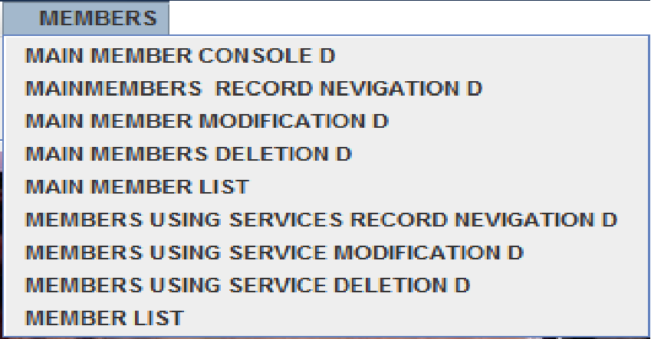

MAIN Member Console | Insertion of MAIN Member records.
MAIN Member Modification | Modification of MAIN Members records.
MAIN Member Deletion | Deletion of MAIN Member records.
MAIN Member Record Navigation | Viewing of MAIN MEMBERS records.
MAIN MEMBER LIST | Viewing of MAIN MEMBERS records IN TABULAR FORM.
Member USING SEVICES Modification | Modification of Member USING SEVICES records.
Member USING SEVICES Deletion | Deletion of Member USING SEVICES records.
Member USING SEVICES Record Navigation | Viewing of Member USING SEVICES records.
MEMBER LIST | Viewing of Member USING SEVICES records IN TABULAR FORM.

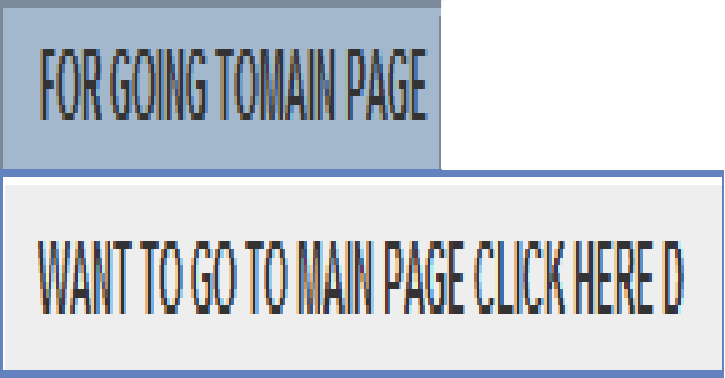

WANT TO GO BACK TO MAIN PAGE CLICK HERE | TO GO TO FIRST ENTRY LEVEL PAGE

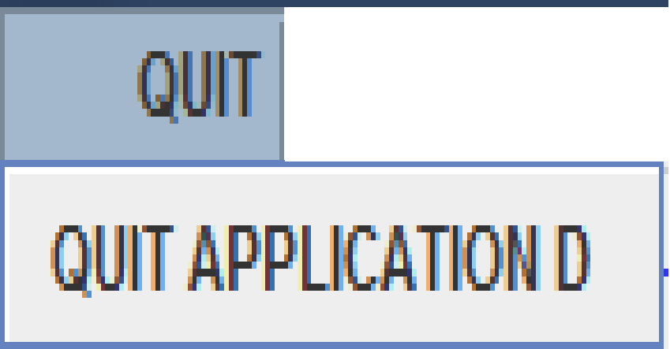

QUIT APPLICATION | TO QUIT THE APPLICATION

6.3 I/O Forms Design & Event Coding:
The software project for TRAVEL AGENCY Management contains various forms along with programming codes. Forms (JFrames) and their event coding are given below.
Commands used to import different libraries
import javax.swing.*;
import java.sql.Connection;
import java.sql.DriverManager;
import java.sql.Statement;
import java.sql.ResultSet;
Main page
private void jButton1ActionPerformed(java.awt.event.ActionEvent evt)
{ new ForMemShip().setVisible(true);
this.setVisible(false }
private void jButton2ActionPerformed(java.awt.event.ActionEvent evt)
{ new PASSWORDFEILD().setVisible(true);
this.setVisible(false);}
private void jButton3ActionPerformed(java.awt.event.ActionEvent evt)
{ System.exit(0); }

PASSWORD FIELD
Statement stmt = null;
ResultSet rs = null; // ResultSet for publisher table.
String sql = null;
private void TOMEMBERSHIPPgeActionPerformed(java.awt.event.ActionEvent evt) {
new ForMemShip().setVisible(true);
this.setVisible(false); // TODO add your handling code here:
}
private void tomainpageActionPerformed(java.awt.event.ActionEvent evt) {
new mainpage().setVisible(true);
this.setVisible(false);
// TODO add your handling code here:
}
private void INTOActionPerformed(java.awt.event.ActionEvent evt) {
int idno=0;
String name = null;
String dno=null;
try {
if(jRadioButton1.isSelected()) {
//REGISTER
Class.forName("com.mysql.jdbc.Driver");
//Class.forName("java.sql.driver");

//CONNECTION
Connection con = (Connection)
DriverManager.getConnection("jdbc:mysql://localhost:3306/travelagency","root","student");

//EXECUTE QUERY
stmt = con.createStatement();
String no=jTextField2.getText();
rs = stmt.executeQuery("SELECT * FROM MMember WHERE MEMB_NO="+no);

while (rs.next()) {
name=rs.getString("memb_name");
idno=rs.getInt("mem_status");
dno=""+idno;
}

String pw=new String(jPasswordField1.getPassword());
String UNAME=jTextField1.getText();

if(UNAME.equals(name) && pw.equals(dno)){
new MAINFORM().setVisible(true);
this.setVisible(false);
}
}
else
if(jRadioButton2.isSelected()) {
//REGISTER
Class.forName("com.mysql.jdbc.Driver");
//Class.forName("java.sql.driver");

//CONNECTION
Connection con = (Connection)
DriverManager.getConnection("jdbc:mysql://localhost:3306/travelagency","root","student");

//EXECUTE QUERY
stmt = con.createStatement();
String no=jTextField2.getText();
rs = stmt.executeQuery("SELECT * FROM Member WHERE MEMB_NO="+no);

while (rs.next()) {
name=rs.getString("memb_name");
idno=rs.getInt("mem_status");
dno=""+idno;
}

String pw=new String(jPasswordField1.getPassword());
String UNAME=jTextField1.getText();

if(UNAME.equals(name) && pw.equals(dno)){
new MAINFORM().setVisible(true);
this.setVisible(false);
}
}
else
{
JOptionPane.showMessageDialog(null, "PLEASE TYPE THE CORRECT PASSWORD AND I.D NO");
}

}
catch(Exception e){
JOptionPane.showMessageDialog(null , e.getMessage()+" "+'\n' + " YOU HAVE AN ERROR IN CONNECTION PLEASE CORRECT IT");
e.printStackTrace();
} // TODO add your handling code here:
}

For membership
Statement stmt = null;
ResultSet rs = null; // ResultSet for publisher table.
String sql = "SELECT * FROM Member;";
private void cmdNewActionPerformed(java.awt.event.ActionEvent evt) {
jTextField9.setText("NON");
cmdSave.setEnabled(true);
try {
//REGISTER
Class.forName("com.mysql.jdbc.Driver");
//Class.forName("java.sql.driver");

//CONNECTION
Connection con = (Connection)
DriverManager.getConnection("jdbc:mysql://localhost:3306/travelagency","root","arjun");

//EXECUTE QUERY
stmt = con.createStatement();
rs = stmt.executeQuery(sql);

//for memb no
int MNO=1000, Mno = 0;
while (rs.next()) {
MNO = rs.getInt("memb_no");
}
MNO++;
Mno = MNO;
jTextField1.setText(Integer.toString(Mno));
//for status
jTextField8.setText(Integer.toString(Mno+100));
jTextField2.setFocusable(true);
}

catch(Exception e){
JOptionPane.showMessageDialog(null ,e.getMessage()+" "+'\n' + " YOU HAVE AN ERROR IN CONNECTION PLEASE CORRECT IT");
e.printStackTrace();}}
private void cmdSaveActionPerformed(java.awt.event.ActionEvent evt) {
try{
//REGISTER
Class.forName("com.mysql.jdbc.Driver");
//Class.forName("java.sql.driver");

//CONNECTION
String db_url="jdbc:mysql://localhost:3306/travelagency";
String pwd="arjun";
String user="root";

Connection conn=(Connection)DriverManager.getConnection(db_url,user,pwd);

//EXECUTED QUERIES
stmt=conn.createStatement();
rs=stmt.executeQuery(sql);
int no=Integer.parseInt(jTextField1.getText());
String name=jTextField2.getText();
String add1=jTextField3.getText();
String add2=jTextField4.getText();
String date=jTextField7.getText();
int status=Integer.parseInt(jTextField8.getText());
String issue=jTextField9.getText();
String pno=jTextField5.getText();
double fee = Double.parseDouble(jTextField6.getText());

int then=JOptionPane.showConfirmDialog(null,"ARE YOU REALLY WANT TO BECOME MEMBER","FOR CONFORMATION",JOptionPane.YES_NO_CANCEL_OPTION, JOptionPane.INFORMATION_MESSAGE);

if(then==JOptionPane.YES_OPTION){
String ssql="INSERT INTO Member(memb_no, memb_name, memb_add, mdate, medate, mfee, mem_status, mem_issue, MEM_phone)values("+(no)+", '"+(name)+"', '"+(add1+add2)+"', '"+(date)+"', '"+(date)+"', "+(fee)+", "+(status)+", '"+(issue)+"', '"+(pno)+"');";
int rowsEffected = stmt.executeUpdate(ssql);

fdialog.setVisible(true);
jLabel12.setText("YOUR USER NAME IS:"+name+" YOUR I.D NO IS:"+status);
}

cmdSave.setEnabled(false);

}
catch(Exception e){
JOptionPane.showMessageDialog(this, e.getMessage()+" "+'\n' + " YOU HAVE AN ERROR IN CONNECTION PLEASE CORRECT IT");
e.printStackTrace();
}}

private void cmdClearActionPerformed(java.awt.event.ActionEvent evt) {
jTextField1.setText("");
jTextField2.setText("");
jTextField5.setText("");
jTextField6.setText("");
jTextField7.setText("");
jTextField3.setText("");
jTextField8.setText("");
jTextField4.setText("");
jTextField9.setText("");
cmdSave.setEnabled(false);
}
private void cmdExitActionPerformed(java.awt.event.ActionEvent evt) {
System.exit(0);}
private void backActionPerformed(java.awt.event.ActionEvent evt) {
new mainpage().setVisible(true);
this.setVisible(false);
// TODO add your handling code here:
}
private void LogINbackActionPerformed(java.awt.event.ActionEvent evt) {
new PASSWORDFEILD().setVisible(true);
this.setVisible(false);// TODO add your handling code here:
}
private void formWindowGainedFocus(java.awt.event.WindowEvent evt) {
jTextField1.setEditable(false);
jTextField8.setEditable(false);
jTextField9.setEditable(false);
cmdSave.setEnabled(false); // TODO add your handling code here:
}

private void jButton1ActionPerformed(java.awt.event.ActionEvent evt) { new MAINFORM().setVisible(true);
this.setVisible(false);
fdialog.setVisible(false);
// TODO add your handling code here:
}

Issue veh
Statement mem = null;
ResultSet rmem = null;
String st1 = "NON";
String meme = "SELECT * FROM Member WHERE mem_issue = '" + st1 + "';";

Statement mm = null;
ResultSet rmm = null;
String st = "NON";
String mme = "SELECT * FROM MMember WHERE mem_issue = '" + st + "';";

Statement ve = null;
ResultSet rve = null;
String st2 = "NON";
String vee= "SELECT * FROM veh WHERE issue_status = '" + st2 + "';";

Statement smissue = null;
ResultSet rsmissue = null;
String m = "SELECT * FROM Missue";

Statement stissue = null;
ResultSet rstissue = null;
String t = "SELECT * FROM Tissue";

private void jList1MouseClicked(java.awt.event.MouseEvent evt) {
// getSelectedValue() method extracts the current cursor location value into a variable
String MembNo = (String) jList1.getSelectedValue();
// Extract the first 4 characters as Member No into a variable
String Mno =MembNo.trim().substring(0, 4);
String quer = "SELECT * FROM Member WHERE memb_no = " + (Mno) + ";";
try {
Class.forName("com.mysql.jdbc.Driver").newInstance();
Connection con = (Connection) DriverManager.getConnection("jdbc:mysql://localhost:3306/travelagency","root","arjun");
// Create SQL statement and execute query.
mem = con.createStatement();
rmem = mem.executeQuery(quer);

if (rmem.next()) {
String MName = rmem.getString("memb_name");
String MDate = rmem.getString("mdate");
String MStatus = rmem.getString("mem_issue");
// Displaying the contents in respective text boxes.
txtMNo.setText(Mno);
txtMName.setText(MName);
txtMDate.setText(MDate);
txtMStatus.setText(MStatus);
} else {
JOptionPane.showMessageDialog(null, "RECORD DOES NOT FOUND IN TABLE");
}
} catch (Exception e) {
JOptionPane.showMessageDialog(this, e.getMessage());
}}
private void formWindowGainedFocus(java.awt.event.WindowEvent evt) {

txtMNo.setEditable(false);
txtMName.setEditable(false);
txtMDate.setEditable(false);
txtMStatus.setEditable(false);
jTextField4.setEditable(false);
jTextField3.setEditable(false);
jTextField2.setEditable(false);
jTextField1.setEditable(false);
jTextField5.setEditable(false);
try {
Class.forName("com.mysql.jdbc.Driver");
Connection con = (Connection)
DriverManager.getConnection("jdbc:mysql://localhost:3306/travelagency","root","arjun");

mem = con.createStatement();
rmem = mem.executeQuery(meme);
//for service users
DefaultListModel dModel = (DefaultListModel) jList1.getModel();
dModel.clear();
while (rmem.next()) {
String Mno = rmem.getString("memb_no");
String MName = rmem.getString("memb_name");
dModel.addElement(Mno + "- " + MName);
}
jList1.setModel(dModel);
//for veh
DefaultListModel fModel = (DefaultListModel) jList2.getModel();
fModel.clear();
ve = con.createStatement();
rve = ve.executeQuery(vee);
while (rve.next()) {
String Ano = rve.getString("v_no");
String BTitle = rve.getString("v_name");
fModel.addElement(Ano + "- " + BTitle);
}
jList2.setModel(fModel);
//for main members
DefaultListModel cModel = (DefaultListModel) jList3.getModel();
cModel.clear();
mm = con.createStatement();
rmm = mm.executeQuery(mme);
while (rmm.next()) {
String Ano = rmm.getString("memb_no");
String BTitle = rmm.getString("memb_name");
cModel.addElement(Ano + "- " + BTitle);
}
jList3.setModel(cModel) }

catch (Exception e) {
JOptionPane.showMessageDialog(this,e.getMessage());
e.printStackTrace();
}
}
private void cmdExitActionPerformed(java.awt.event.ActionEvent evt) {
this.setVisible(false);
}

private void jList2MouseClicked(java.awt.event.MouseEvent evt) {
// getSelectedValue() method extracts the current cursor location value into a variable
String MembNo = (String) jList2.getSelectedValue();
// Extract the first 4 characters as Member No into a variable
String Mno =MembNo.trim().substring(0, 4);
String quer = "SELECT * FROM veh WHERE v_no = " +(Mno)+ ";";
try {
Class.forName("com.mysql.jdbc.Driver").newInstance();
Connection con = (Connection) DriverManager.getConnection("jdbc:mysql://localhost:3306/travelagency","root","arjun");
// Create SQL statement and execute query.
ve = con.createStatement();
rve = ve.executeQuery(quer);
if (rve.next()) {
String MName = rve.getString("v_name");
String disc = rve.getString("otr_disc");
String MStatus = rve.getString("issue_status");

jTextField1.setText(Mno);
jTextField2.setText(MName);
jTextField3.setText(disc);
jTextField4.setText(Mno);
jTextField5.setText(MStatus); }
else {
JOptionPane.showMessageDialog(null, "RECORD DOES NOT FOUND IN TABLE");
}
}
catch (Exception e) {
JOptionPane.showMessageDialog(this, e.getMessage());
}
}

private void cmdIssueActionPerformed(java.awt.event.ActionEvent evt) {
try {
Class.forName("com.mysql.jdbc.Driver");
Connection con = (Connection)
DriverManager.getConnection("jdbc:mysql://localhost:3306/travelagency","root","arjun");
smissue = con.createStatement();
rsmissue =smissue.executeQuery(m);
stissue = con.createStatement();
rstissue = stissue.executeQuery(t);
int Acno = Integer.parseInt(jTextField1.getText().trim());
int Mno = Integer.parseInt(txtMNo.getText().trim());
String idt = txtIDate.getText();
String rdt = idt; // Temporarily assigned for testing purpose
int code = JOptionPane.showConfirmDialog(this, "Are you sure to add?", "Confirmation Dialog Box", JOptionPane.YES_NO_CANCEL_OPTION, JOptionPane.INFORMATION_MESSAGE);
if (code == JOptionPane.YES_OPTION) {
// Record updated into Missue and Tissue tables
String strSQL = "INSERT INTO Missue(acc_no, memb_no, idate, rdate) VALUES ("+(Acno)+", "+(Mno)+", '"+(idt)+"', '"+(rdt)+"')";
String strSQL1 = "INSERT INTO Tissue(acc_no, memb_no, idate, rdate) VALUES ("+(Acno)+", "+(Mno)+", '"+(idt)+"', '"+(rdt)+"')";
int rowEffected = smissue.executeUpdate(strSQL);
int rowsEffected = stissue.executeUpdate(strSQL1);
String sta = "YES"; // Lib table
String strSQLa = "Update veh set issue_status ='"+(sta)+"' where v_no = " + (Acno)+"";
ve.executeUpdate(strSQLa);
if(Mno>7000){
String stb = "YES"; // Member table
String strSQLb = "Update MMember set mem_issue ='"+(stb)+"' where memb_no = " + (Mno);
mm.executeUpdate(strSQLb);
JOptionPane.showMessageDialog(this, "Record update successfully");
}
else
{
String stb = "YES"; // Member table
String strSQLb = "Update Member set mem_issue ='"+(stb)+"' where memb_no = " + (Mno);
mem.executeUpdate(strSQLb);
JOptionPane.showMessageDialog(this, "Record update successfully"
+ '\n'+"thanks have a nice journey");
}}
} catch (Exception e) {
JOptionPane.showMessageDialog(this, e.getMessage());
}
}

private void jButton1ActionPerformed(java.awt.event.ActionEvent evt) {
new MAINFORM().setVisible(true);
this.setVisible(false);
// TODO add your handling code here:
}
private void jList3MouseClicked(java.awt.event.MouseEvent evt) {
// getSelectedValue() method extracts the current cursor location value into a variable
String MembNo = (String) jList3.getSelectedValue();
// Extract the first 4 characters as Member No into a variable
String Mno =MembNo.trim().substring(0, 4);
String quer = "SELECT * FROM MMember WHERE memb_no = " + (Mno) + ";";
try {
Class.forName("com.mysql.jdbc.Driver").newInstance();
Connection con = (Connection) DriverManager.getConnection("jdbc:mysql://localhost:3306/travelagency","root","arjun");
// Create SQL statement and execute query.
mm = con.createStatement();
rmm = mm.executeQuery(quer);
if ( rmm.next()) {
String MName = rmm.getString("memb_name");
String MDate = rmm.getString("mdate");
String MStatus = rmm.getString("mem_issue");
// Displaying the contents in respective text boxes.
txtMNo.setText(Mno);
txtMName.setText(MName);
txtMDate.setText(MDate);
txtMStatus.setText(MStatus);
} else {
JOptionPane.showMessageDialog(null, "RECORD DOES NOT FOUND IN TABLE");
}
} catch (Exception e) {
JOptionPane.showMessageDialog(this, e.getMessage());
} // TODO add your handling code here:
}

main form
private void jMenuItem13ActionPerformed(java.awt.event.ActionEvent evt) {
new vehmod().setVisible(true);
this.setVisible(false); // TODO add your handling code here:
}
private void MAINPAGEGOActionPerformed(java.awt.event.ActionEvent evt) {
new mainpage().setVisible(true);
this.setVisible(false);
}
private void QUITAPPActionPerformed(java.awt.event.ActionEvent evt) {
System.exit(0);
}
private void VEHCONSOLEActionPerformed(java.awt.event.ActionEvent evt) {
new PASSWORDFEILD1().setVisible(true);
this.setVisible(false);
// TODO add your handling code here:
}
private void MODActionPerformed(java.awt.event.ActionEvent evt) {
// TODO add your handling code here:
}
private void MODActionPerformed1(java.awt.event.ActionEvent evt) {
new PASSWORDFEILD1().setVisible(true);
this.setVisible(false);
// TODO add your handling code here:
}
private void DELActionPerformed(java.awt.event.ActionEvent evt) {
new PASSWORDFEILD1().setVisible(true);
this.setVisible(false);
// TODO add your handling code here:
}
private void ISSUEActionPerformed(java.awt.event.ActionEvent evt) {
new Issueveh().setVisible(true);
this.setVisible(false);
// TODO add your handling code here:
}
private void RETURNActionPerformed(java.awt.event.ActionEvent evt) {
new Returnveh().setVisible(true);
this.setVisible(false);
// TODO add your handling code here:
}
private void AVAILABLEActionPerformed(java.awt.event.ActionEvent evt) {

new avilableveh().setVisible(true);
this.setVisible(false);// TODO add your handling code here:
}
private void ONBOOKActionPerformed(java.awt.event.ActionEvent evt) {
new ONBOOK().setVisible(true);
this.setVisible(false);
// TODO add your handling code here:
}
private void MAINMEMBERSRECNAVActionPerformed(java.awt.event.ActionEvent evt) {
new MAINMEMBNAV().setVisible(true);
this.setVisible(false); // TODO add your handling code here:
}
private void MEMBERActionPerformed(java.awt.event.ActionEvent evt) {
new MEMBNAV().setVisible(true);
this.setVisible(false);
// TODO add your handling code here:
}
private void MMMODActionPerformed(java.awt.event.ActionEvent evt) {
new MainMembmod().setVisible(true);
this.setVisible(false);
// TODO add your handling code here:
}
private void MMODActionPerformed(java.awt.event.ActionEvent evt) {
new Membmod().setVisible(true);
this.setVisible(false); // TODO add your handling code here:
}
private void MDELActionPerformed(java.awt.event.ActionEvent evt) {
new MembDel().setVisible(true);
this.setVisible(false); // TODO add your handling code here:
}
private void MEMBERSRECNAVActionPerformed(java.awt.event.ActionEvent evt) {
new MEMBNAV().setVisible(true);
this.setVisible(false); // TODO add your handling code here:
}
private void TYPEAVAActionPerformed(java.awt.event.ActionEvent evt) {
new TYPE_V().setVisible(true);
this.setVisible(false); // TODO add your handling code here:
}
private void DELETIONActionPerformed(java.awt.event.ActionEvent evt) {
new PASSWORDFEILD1().setVisible(true);
this.setVisible(false);
// TODO add your handling code here:
}
private void MODIFICATIONActionPerformed1(java.awt.event.ActionEvent evt) {
new PASSWORDFEILD1().setVisible(true);
this.setVisible(false);
// TODO add your handling code here:
}
private void TOTALVEHActionPerformed(java.awt.event.ActionEvent evt) {
new TVEH().setVisible(true);
this.setVisible(false);
// TODO add your handling code here:
}
private void VEHRECNAVActionPerformed(java.awt.event.ActionEvent evt) {
new vehrecnav().setVisible(true);
this.setVisible(false);
// TODO add your handling code here:
}
private void MMDELActionPerformed(java.awt.event.ActionEvent evt) {
new PASSWORDFEILD2().setVisible(true);
this.setVisible(false); // TODO add your handling code here:
}
private void MAINMEMCONActionPerformed(java.awt.event.ActionEvent evt) {
new PASSWORDFEILD2().setVisible(true);
this.setVisible(false); // TODO add your handling code here:
}
private void MAINMEMBERSRECNAVActionPerformed1(java.awt.event.ActionEvent evt) {
new MAINMEMBNAV().setVisible(true);
this.setVisible(false); // TODO add your handling code here:
}
private void MMEMMODActionPerformed(java.awt.event.ActionEvent evt) {
new PASSWORDFEILD2().setVisible(true);
this.setVisible(false); // TODO add your handling code here:
}
private void TYPEMODActionPerformed(java.awt.event.ActionEvent evt) {
new PASSWORDFEILD1().setVisible(true);
this.setVisible(false); // TODO add your handling code here:
}
private void TYPEDELActionPerformed(java.awt.event.ActionEvent evt) {
new PASSWORDFEILD1().setVisible(true);
this.setVisible(false); // TODO add your handling code here:
}
private void TYPECONActionPerformed(java.awt.event.ActionEvent evt) {
new PASSWORDFEILD1().setVisible(true);
this.setVisible(false); // TODO add your handling code here:
}
private void MMLISTActionPerformed(java.awt.event.ActionEvent evt) {
new MMList().setVisible(true);
this.setVisible(false); // TODO add your handling code here:
}
private void MLISTActionPerformed(java.awt.event.ActionEvent evt) {
new MList().setVisible(true);
this.setVisible(false); // TODO add your handling code here:
}
Main member imformation
Statement stmt = null;
ResultSet rs = null;
String SQL = "SELECT * FROM MMember";
public void disable_textfields() {
txtMNo.setEditable(false);
txtMName.setEditable(false);
txtMAdd.setEditable(false);
txtMPh.setEditable(false);
txtMDate.setEditable(false);
txtMFee.setEditable(false);
// txtMStatus.setEditable(false);
txtMIssue.setEditable(false);
}

private void cmdPrevActionPerformed(java.awt.event.ActionEvent evt) {
try {
Class.forName("com.mysql.jdbc.Driver");
Connection con = (Connection)
DriverManager.getConnection("jdbc:mysql://localhost:3306/travelagency","root","arjun");
if (rs.previous()) {
String Mno = rs.getString("memb_no");
String MName = rs.getString("memb_name");
String MAdd = rs.getString("memb_add");
String MPh1 = rs.getString("memb_phone");
String MDate = rs.getString("mdate");
String MEDate = rs.getString("medate");
String MFee = rs.getString("mfee");
String MStatus = rs.getString("mem_status");
String MIssue = rs.getString("mem_issue");
// Displaying the contents in respective text boxes.
txtMNo.setText(Mno);
txtMName.setText(MName);
txtMAdd.setText(MAdd);
txtMPh.setText(MPh1);
txtMDate.setText(MDate);
txtMFee.setText(MFee);
// txtMStatus.setText(MStatus);
txtMIssue.setText(MIssue);
cmdFirst.setEnabled(true);
cmdNext.setEnabled(true);
cmdPrev.setEnabled(true);
cmdLast.setEnabled(true);
jTextField12.setText(Mno);
} else {
cmdPrev.setEnabled(false);
JOptionPane.showMessageDialog(this, "You are at first position", "Student",0);
}
} catch (Exception e) {
JOptionPane.showMessageDialog(this, e.getMessage());
}

}

private void cmdLastActionPerformed(java.awt.event.ActionEvent evt) {

try {
Class.forName("com.mysql.jdbc.Driver");
Connection con = (Connection)
DriverManager.getConnection("jdbc:mysql://localhost:3306/travelagency","root","arjun");
if (rs.last()) {
String Mno = rs.getString("memb_no");
String MName = rs.getString("memb_name");
String MAdd = rs.getString("memb_add");
String MPh1 = rs.getString("memb_phone");
String MDate = rs.getString("mdate");
String MEDate = rs.getString("medate");
String MFee = rs.getString("mfee");
String MStatus = rs.getString("mem_status");
String MIssue = rs.getString("mem_issue");
// Displaying the contents in respective text boxes.
txtMNo.setText(Mno);
txtMName.setText(MName);
txtMAdd.setText(MAdd);
txtMPh.setText(MPh1);
txtMDate.setText(MDate);
txtMFee.setText(MFee);
// txtMStatus.setText(MStatus);
txtMIssue.setText(MIssue);
cmdFirst.setEnabled(true);
cmdNext.setEnabled(false);
cmdPrev.setEnabled(true);
cmdLast.setEnabled(false);
jTextField12.setText(Mno);
} else {
JOptionPane.showMessageDialog(this, "You are already at last record", "Student",0);
}
} catch (Exception e) {
JOptionPane.showMessageDialog(this, e.getMessage());
}
}

private void cmdNextActionPerformed(java.awt.event.ActionEvent evt) {
try {
Class.forName("com.mysql.jdbc.Driver");
Connection con = (Connection)
DriverManager.getConnection("jdbc:mysql://localhost:3306/travelagency","root","arjun");
if (rs.next()) {
String Mno = rs.getString("memb_no");
String MName = rs.getString("memb_name");
String MAdd = rs.getString("memb_add");
String MPh1 = rs.getString("memb_phone");
String MDate = rs.getString("mdate");
String MEDate = rs.getString("medate");
String MFee = rs.getString("mfee");
String MStatus = rs.getString("mem_status");
String MIssue = rs.getString("mem_issue");
// Displaying the contents in respective text boxes.
txtMNo.setText(Mno);
txtMName.setText(MName);
txtMAdd.setText(MAdd);
txtMPh.setText(MPh1);
txtMDate.setText(MDate);
txtMFee.setText(MFee);
// txtMStatus.setText(MStatus);
txtMIssue.setText(MIssue);
cmdFirst.setEnabled(true);
cmdNext.setEnabled(true);
cmdPrev.setEnabled(true);
cmdLast.setEnabled(true);
jTextField12.setText(Mno);
} else {
cmdNext.setEnabled(false);
JOptionPane.showMessageDialog(this, "You are at last record position", "Student",0);
}
} catch (Exception e) {
JOptionPane.showMessageDialog(this, e.getMessage());}
}
private void cmdExitActionPerformed(java.awt.event.ActionEvent evt) {
this.setVisible(false);
}
private void cmdFirstActionPerformed(java.awt.event.ActionEvent evt) {
try {
Class.forName("com.mysql.jdbc.Driver");
Connection con = (Connection)
DriverManager.getConnection("jdbc:mysql://localhost:3306/travelagency","root","arjun");
if (rs.first()) {
String Mno = rs.getString("memb_no");
String MName = rs.getString("memb_name");
String MAdd = rs.getString("memb_add");
String MPh1 = rs.getString("memb_phone");
String MDate = rs.getString("mdate");
String MEDate = rs.getString("medate");
String MFee = rs.getString("mfee");
String MStatus = rs.getString("mem_status");
String MIssue = rs.getString("mem_issue");
// Displaying the contents in respective text boxes.
txtMNo.setText(Mno);
txtMName.setText(MName);
txtMAdd.setText(MAdd);
txtMPh.setText(MPh1);
txtMDate.setText(MDate);
txtMFee.setText(MFee);
// txtMStatus.setText(MStatus);
txtMIssue.setText(MIssue);
cmdFirst.setEnabled(false);
cmdNext.setEnabled(true);
cmdPrev.setEnabled(false);
cmdLast.setEnabled(true);
jTextField12.setText(Mno);
} else {
cmdFirst.setEnabled(false);
cmdNext.setEnabled(false);
cmdPrev.setEnabled(false);
cmdLast.setEnabled(false);
JOptionPane.showMessageDialog(this, "Rhere is no record in table", "Student",0);
}
} catch (Exception e) {
JOptionPane.showMessageDialog(this, e.getMessage());
}

}
private void formWindowGainedFocus(java.awt.event.WindowEvent evt) {
disable_textfields();
try {
Class.forName("com.mysql.jdbc.Driver");
Connection con = (Connection)
DriverManager.getConnection("jdbc:mysql://localhost:3306/travelagency","root","arjun");
stmt = con.createStatement();
rs = stmt.executeQuery(SQL);
if (rs.first())
{
String Mno = rs.getString("memb_no");
String MName = rs.getString("memb_name");
String MAdd = rs.getString("memb_add");
String MPh1 = rs.getString("memb_phone");
String MDate = rs.getString("mdate");
String MEDate = rs.getString("medate");
String MFee = rs.getString("mfee");
String MStatus = rs.getString("mem_status");
String MIssue = rs.getString("mem_issue");
// Displaying the contents in respective text boxes.
txtMNo.setText(Mno);
txtMName.setText(MName);
txtMAdd.setText(MAdd);
txtMPh.setText(MPh1);
txtMDate.setText(MDate);
txtMFee.setText(MFee);
txtMIssue.setText(MIssue);
cmdFirst.setEnabled(false);
cmdNext.setEnabled(true);
cmdPrev.setEnabled(false);
cmdLast.setEnabled(true);
jTextField12.setText(Mno);
}
else
{
cmdFirst.setEnabled(false);
cmdNext.setEnabled(false);
cmdPrev.setEnabled(false);
cmdLast.setEnabled(false);
JOptionPane.showMessageDialog(this, "Rhere is no record in table", "Student",0);
}
} catch (Exception e) {
JOptionPane.showMessageDialog(this, e.getMessage());
}
}
private void jButton1ActionPerformed(java.awt.event.ActionEvent evt) {
new MAINFORM().setVisible(true);
this.setVisible(false); // TODO add your handling code here:
}
private void GETRECActionPerformed(java.awt.event.ActionEvent evt) {
String num=jTextField12.getText();
try {
//REGISTER
Class.forName("com.mysql.jdbc.Driver");
//Class.forName("java.sql.driver");

//CONNECTION
String db_url="jdbc:mysql://localhost:3306/travelagency";
String pwd="arjun";
String user="root";

Connection conn=(Connection)DriverManager.getConnection(db_url,user,pwd);

//EXECUTED QUERIES
stmt=(Statement) conn.createStatement();

rs=stmt.executeQuery( "SELECT * FROM MMEMBER WHERE MEMB_NO="+num);

if (rs.next()) {
String Mno = rs.getString("memb_no");
String MName = rs.getString("memb_name");
String MAdd = rs.getString("memb_add");
String MPh1 = rs.getString("memB_phone");
String MDate = rs.getString("mdate");
String MEDate = rs.getString("medate");
String MFee = rs.getString("mfee");
String MStatus = rs.getString("mem_status");
String MIssue = rs.getString("mem_issue");
// Displaying the contents in respective text boxes.
txtMNo.setText(Mno);
txtMName.setText(MName);
txtMAdd.setText(MAdd);
txtMPh.setText(MPh1);
txtMDate.setText(MDate);
txtMFee.setText(MFee);
// txtMStatus.setText(MStatus);
txtMIssue.setText(MIssue);
jTextField12.setText(Mno);
} else {
JOptionPane.showMessageDialog(null, "RECORD DOES NOT FOUND IN VEH TABLE"+'\n'+"THE VEH_NO IS WRONG");
}
} catch(Exception e) {
JOptionPane.showMessageDialog(this, e.getMessage()+" "+'\n' + " YOU HAVE AN ERROR IN CONNECTION PLEASE CORRECT IT");
e.printStackTrace();
}
// TODO add your handling code here:
}

Main member ship
Statement stmt = null;
ResultSet rs = null; // ResultSet for publisher table.
String sql = "SELECT * FROM MMember";
private void cmdNewActionPerformed(java.awt.event.ActionEvent evt) {
jTextField9.setText("NON");
cmdSave.setEnabled(true);
try {
//REGISTER
Class.forName("com.mysql.jdbc.Driver");
//Class.forName("java.sql.driver");

//CONNECTION
Connection con = (Connection)
DriverManager.getConnection("jdbc:mysql://localhost:3306/travelagency","root","arjun");

//EXECUTE QUERY
stmt = con.createStatement();
rs = stmt.executeQuery("SELECT * FROM MMember");

//for memb no
int MNO=7000, Mno = 0;
while (rs.next()) {
MNO = rs.getInt("memb_no");
}
MNO++;
Mno = MNO;
jTextField1.setText(Integer.toString(Mno));
//for status
jTextField8.setText(Integer.toString(Mno+100));
jTextField2.setFocusable(true);
}

catch(Exception e){
JOptionPane.showMessageDialog(null ,e.getMessage()+" "+'\n' + " YOU HAVE AN ERROR IN CONNECTION PLEASE CORRECT IT");
e.printStackTrace();
}}
private void cmdSaveActionPerformed(java.awt.event.ActionEvent evt) {
try{
//REGISTER
Class.forName("com.mysql.jdbc.Driver");
//Class.forName("java.sql.driver");

//CONNECTION
String db_url="jdbc:mysql://localhost:3306/travelagency";
String pwd="arjun";
String user="root";

Connection conn=(Connection)DriverManager.getConnection(db_url,user,pwd);

//EXECUTED QUERIES
stmt=conn.createStatement();

rs=stmt.executeQuery(sql);

int no=Integer.parseInt(jTextField1.getText());
String name=jTextField2.getText();
String add1=jTextField3.getText();
String add2=jTextField4.getText();
String date=jTextField7.getText();
int status=Integer.parseInt(jTextField8.getText());
String issue=jTextField9.getText();
String pno=jTextField5.getText();
double fee = Double.parseDouble(jTextField6.getText());

int then=JOptionPane.showConfirmDialog(null,"ARE YOU REALLY WANT TO BECOME MEMBER","FOR CONFORMATION",JOptionPane.YES_NO_CANCEL_OPTION, JOptionPane.INFORMATION_MESSAGE);

if(then==JOptionPane.YES_OPTION){
String ssql="INSERT INTO MMember(memb_no, memb_name, memb_add, mdate, medate, mfee, mem_status, mem_issue, MEMB_phone)values("+(no)+", '"+(name)+"', '"+(add1+add2)+"', '"+(date)+"', '"+(date)+"', "+(fee)+", "+(status)+", '"+(issue)+"', '"+(pno)+"');";
int rowsEffected = stmt.executeUpdate(ssql);

fdialog.setVisible(true);
jLabel12.setText("YOUR USER NAME IS:"+name+" YOUR I.D NO IS:"+status);
}

cmdSave.setEnabled(false);

}
catch(Exception e){
JOptionPane.showMessageDialog(this, e.getMessage()+" "+'\n' + " YOU HAVE AN ERROR IN CONNECTION PLEASE CORRECT IT");
e.printStackTrace();
}}

private void cmdClearActionPerformed(java.awt.event.ActionEvent evt) {
jTextField1.setText("");
jTextField2.setText("");
jTextField5.setText("");
jTextField6.setText("");
jTextField7.setText("");
jTextField3.setText("");
jTextField8.setText("");
jTextField4.setText("");
jTextField9.setText("");
cmdSave.setEnabled(false);
}
private void cmdExitActionPerformed(java.awt.event.ActionEvent evt) {
System.exit(0);
}
private void backActionPerformed(java.awt.event.ActionEvent evt) {
new MAINFORM().setVisible(true);
this.setVisible(false);
// TODO add your handling code here:
}
private void LogINbackActionPerformed(java.awt.event.ActionEvent evt) {

new PASSWORDFEILD2().setVisible(true);
this.setVisible(false);// TODO add your handling code here:
}

private void formWindowGainedFocus(java.awt.event.WindowEvent evt) {
jTextField1.setEditable(false);
jTextField8.setEditable(false);
jTextField9.setEditable(false);
cmdSave.setEnabled(false); // TODO add your handling code here:
}

private void jButton1ActionPerformed(java.awt.event.ActionEvent evt) {

new MAINFORM().setVisible(true);
this.setVisible(false);
fdialog.setVisible(false);
// TODO add your handling code here:
}
Memb rec nav
Statement stmt = null;
ResultSet rs = null;
String SQL = "SELECT * FROM Member";
public void disable_textfields() {
txtMNo.setEditable(false);
txtMName.setEditable(false);
txtMAdd.setEditable(false);
txtMPh.setEditable(false);
txtMDate.setEditable(false);
txtMFee.setEditable(false);
txtMStatus.setEditable(false);
txtMIssue.setEditable(false);
}
private void cmdPrevActionPerformed(java.awt.event.ActionEvent evt) {
try {
Class.forName("com.mysql.jdbc.Driver");
Connection con = (Connection)
DriverManager.getConnection("jdbc:mysql://localhost:3306/travelagency","root","arjun");
if (rs.previous()) {
String Mno = rs.getString("memb_no");
String MName = rs.getString("memb_name");
String MAdd = rs.getString("memb_add");
String MPh1 = rs.getString("mem_phone");
String MDate = rs.getString("mdate");
String MEDate = rs.getString("medate");
String MFee = rs.getString("mfee");
String MStatus = rs.getString("mem_status");
String MIssue = rs.getString("mem_issue");
// Displaying the contents in respective text boxes.
txtMNo.setText(Mno);
txtMName.setText(MName);
txtMAdd.setText(MAdd);
txtMPh.setText(MPh1);
txtMDate.setText(MDate);
txtMFee.setText(MFee);
txtMStatus.setText(MStatus);
txtMIssue.setText(MIssue);
cmdFirst.setEnabled(true);
cmdNext.setEnabled(true);
cmdPrev.setEnabled(true);
cmdLast.setEnabled(true);
jTextField12.setText(Mno);
} else {
cmdPrev.setEnabled(false);
JOptionPane.showMessageDialog(this, "You are at first position", "Student",0);
}
} catch (Exception e) {
JOptionPane.showMessageDialog(this, e.getMessage());
}

}

private void cmdLastActionPerformed(java.awt.event.ActionEvent evt) {
try {
Class.forName("com.mysql.jdbc.Driver");
Connection con = (Connection)
DriverManager.getConnection("jdbc:mysql://localhost:3306/travelagency","root","arjun");
if (rs.last()) {
String Mno = rs.getString("memb_no");
String MName = rs.getString("memb_name");
String MAdd = rs.getString("memb_add");
String MPh1 = rs.getString("mem_phone");
String MDate = rs.getString("mdate");
String MEDate = rs.getString("medate");
String MFee = rs.getString("mfee");
String MStatus = rs.getString("mem_status");
String MIssue = rs.getString("mem_issue");
// Displaying the contents in respective text boxes.
txtMNo.setText(Mno);
txtMName.setText(MName);
txtMAdd.setText(MAdd);
txtMPh.setText(MPh1);
txtMDate.setText(MDate);
txtMFee.setText(MFee);
txtMStatus.setText(MStatus);
txtMIssue.setText(MIssue);
cmdFirst.setEnabled(true);
cmdNext.setEnabled(false);
cmdPrev.setEnabled(true);
cmdLast.setEnabled(false);
jTextField12.setText(Mno);
} else {
JOptionPane.showMessageDialog(this, "You are already at last record", "Student",0);
}
} catch (Exception e) {
JOptionPane.showMessageDialog(this, e.getMessage());}

private void cmdNextActionPerformed(java.awt.event.ActionEvent evt) {
try {
Class.forName("com.mysql.jdbc.Driver");
Connection con = (Connection)
DriverManager.getConnection("jdbc:mysql://localhost:3306/travelagency","root","arjun");
if (rs.next()) {
String Mno = rs.getString("memb_no");
String MName = rs.getString("memb_name");
String MAdd = rs.getString("memb_add");
String MPh1 = rs.getString("mem_phone");
String MDate = rs.getString("mdate");
String MEDate = rs.getString("medate");
String MFee = rs.getString("mfee");
String MStatus = rs.getString("mem_status");
String MIssue = rs.getString("mem_issue");
// Displaying the contents in respective text boxes.
txtMNo.setText(Mno);
txtMName.setText(MName);
txtMAdd.setText(MAdd);
txtMPh.setText(MPh1);
txtMDate.setText(MDate);
txtMFee.setText(MFee);
txtMStatus.setText(MStatus);
txtMIssue.setText(MIssue);
cmdFirst.setEnabled(true);
cmdNext.setEnabled(true);
cmdPrev.setEnabled(true);
cmdLast.setEnabled(true);
jTextField12.setText(Mno);
} else {
cmdNext.setEnabled(false);
JOptionPane.showMessageDialog(this, "You are at last record position", "Student",0);
}
} catch (Exception e) {
JOptionPane.showMessageDialog(this, e.getMessage());
}
}

private void cmdExitActionPerformed(java.awt.event.ActionEvent evt) {
this.setVisible(false);
}

private void cmdFirstActionPerformed(java.awt.event.ActionEvent evt) {
try {
Class.forName("com.mysql.jdbc.Driver");
Connection con = (Connection)
DriverManager.getConnection("jdbc:mysql://localhost:3306/travelagency","root","arjun");
if (rs.first()) {
String Mno = rs.getString("memb_no");
String MName = rs.getString("memb_name");
String MAdd = rs.getString("memb_add");
String MPh1 = rs.getString("mem_phone");
String MDate = rs.getString("mdate");
String MEDate = rs.getString("medate");
String MFee = rs.getString("mfee");
String MStatus = rs.getString("mem_status");
String MIssue = rs.getString("mem_issue");
// Displaying the contents in respective text boxes.
txtMNo.setText(Mno);
txtMName.setText(MName);
txtMAdd.setText(MAdd);
txtMPh.setText(MPh1);
txtMDate.setText(MDate);
txtMFee.setText(MFee);
txtMStatus.setText(MStatus);
txtMIssue.setText(MIssue);
cmdFirst.setEnabled(false);
cmdNext.setEnabled(true);
cmdPrev.setEnabled(false);
cmdLast.setEnabled(true);
jTextField12.setText(Mno);
} else {
cmdFirst.setEnabled(false);
cmdNext.setEnabled(false);
cmdPrev.setEnabled(false);
cmdLast.setEnabled(false);
JOptionPane.showMessageDialog(this, "Rhere is no record in table", "Student",0);
}
} catch (Exception e) {
JOptionPane.showMessageDialog(this, e.getMessage());}

private void formWindowGainedFocus(java.awt.event.WindowEvent evt) {
disable_textfields();
try {
Class.forName("com.mysql.jdbc.Driver");
Connection con = (Connection)
DriverManager.getConnection("jdbc:mysql://localhost:3306/travelagency","root","arjun");
stmt = con.createStatement();
rs = stmt.executeQuery(SQL);
if (rs.first())
{
String Mno = rs.getString("memb_no");
String MName = rs.getString("memb_name");
String MAdd = rs.getString("memb_add");
String MPh1 = rs.getString("mem_phone");
String MDate = rs.getString("mdate");
String MEDate = rs.getString("medate");
String MFee = rs.getString("mfee");
String MStatus = rs.getString("mem_status");
String MIssue = rs.getString("mem_issue");
// Displaying the contents in respective text boxes.
txtMNo.setText(Mno);
txtMName.setText(MName);
txtMAdd.setText(MAdd);
txtMPh.setText(MPh1);
txtMDate.setText(MDate);
txtMFee.setText(MFee);
txtMStatus.setText(MStatus);
txtMIssue.setText(MIssue);
cmdFirst.setEnabled(false);
cmdNext.setEnabled(true);
cmdPrev.setEnabled(false);
cmdLast.setEnabled(true);
jTextField12.setText(Mno);
}
else
{
cmdFirst.setEnabled(false);
cmdNext.setEnabled(false);
cmdPrev.setEnabled(false);
cmdLast.setEnabled(false);
JOptionPane.showMessageDialog(this, "Rhere is no record in table", "Student",0);
}
} catch (Exception e) {
JOptionPane.showMessageDialog(this, e.getMessage());}

private void jButton1ActionPerformed(java.awt.event.ActionEvent evt) {
new MAINFORM().setVisible(true);
this.setVisible(false); // TODO add your handling code here:
}

private void GETRECActionPerformed(java.awt.event.ActionEvent evt) {
String num=jTextField12.getText();
try {
//REGISTER
Class.forName("com.mysql.jdbc.Driver");
//Class.forName("java.sql.driver");

//CONNECTION
String db_url="jdbc:mysql://localhost:3306/travelagency";
String pwd="arjun";
String user="root";

Connection conn=(Connection)DriverManager.getConnection(db_url,user,pwd);

//EXECUTED QUERIES
stmt=(Statement) conn.createStatement();

rs=stmt.executeQuery( "SELECT * FROM MEMBER WHERE MEMB_NO="+num);

if (rs.next()) {
String Mno = rs.getString("memb_no");
String MName = rs.getString("memb_name");
String MAdd = rs.getString("memb_add");
String MPh1 = rs.getString("mem_phone");
String MDate = rs.getString("mdate");
String MEDate = rs.getString("medate");
String MFee = rs.getString("mfee");
String MStatus = rs.getString("mem_status");
String MIssue = rs.getString("mem_issue");
// Displaying the contents in respective text boxes.
txtMNo.setText(Mno);
txtMName.setText(MName);
txtMAdd.setText(MAdd);
txtMPh.setText(MPh1);
txtMDate.setText(MDate);
txtMFee.setText(MFee);
txtMStatus.setText(MStatus);
txtMIssue.setText(MIssue);
jTextField12.setText(Mno);
} else {
JOptionPane.showMessageDialog(null, "RECORD DOES NOT FOUND IN VEH TABLE"+'\n'+"THE VEH_NO IS WRONG");
}

} catch(Exception e) {
JOptionPane.showMessageDialog(this, e.getMessage()+" "+'\n' + " YOU HAVE AN ERROR IN CONNECTION PLEASE CORRECT IT");
e.printStackTrace();
} }
Member rec deletion
Statement stmt = null;
ResultSet rs = null;
String SQL = "SELECT * FROM Member";
private void jList1MouseClicked(java.awt.event.MouseEvent evt) {
// getSelectedValue() method extracts the current cursor location value into a variable
String MembNo = (String) jList1.getSelectedValue();
// Extract the first 4 characters as Member No into a variable
String Mno =MembNo.trim().substring(0, 4);
String query = "SELECT * FROM Member WHERE memb_no = " + (Mno) + ";";
try {
Class.forName("com.mysql.jdbc.Driver").newInstance();
Connection con = (Connection) DriverManager.getConnection("jdbc:mysql://localhost:3306/travelagency","root","arjun");
// Create SQL statement and execute query.
stmt = con.createStatement();
rs = stmt.executeQuery(query);

if (rs.next()) {

String MName = rs.getString("memb_name");
String MAdd = rs.getString("memb_add");
String MPh1 = rs.getString("mem_phone");
String MDate = rs.getString("mdate");
String MEDate = rs.getString("medate");
String MFee = rs.getString("mfee");
String MStatus = rs.getString("mem_status");
String MIssue = rs.getString("mem_issue");

// Displaying the contents in respective text boxes.
txtMNo.setText(Mno);
txtMName.setText(MName);
txtMAdd.setText(MAdd);
txtMPh.setText(MPh1);
txtMDate.setText(MDate);
txtMFee.setText(MFee);
txtMStatus.setText(MStatus);
txtMStatus.setEditable(false);
} else {
JOptionPane.showMessageDialog(null, "Record does not found in Member table");
}
} catch (Exception e) {
JOptionPane.showMessageDialog(this, e.getMessage());
}
}

private void cmdExit1ActionPerformed(java.awt.event.ActionEvent evt) {
this.setVisible(false);
//new MainUI().setVisible(true);
}

private void cmdDeleteActionPerformed(java.awt.event.ActionEvent evt) {

try {
Class.forName("com.mysql.jdbc.Driver");
Connection con = (Connection)
DriverManager.getConnection("jdbc:mysql://localhost:3306/travelagency","root","arjun");
stmt = con.createStatement();
rs = stmt.executeQuery(SQL);
int Mno = Integer.parseInt(txtMNo.getText().trim());
// Steps to confirm deletion
int opt = JOptionPane.showConfirmDialog(null, "Are you sure to delete this record ?");
if (opt == JOptionPane.YES_OPTION) {
try {
// Member table
String strSQL = "delete from member where memb_no="+Mno ;
int rowsEffected = stmt.executeUpdate(strSQL);

if (rowsEffected == 0)
JOptionPane.showMessageDialog(this, "Record does not exists");
else {
JOptionPane.showMessageDialog(this,"Record Deleted");
// Text boxes cleared
txtMNo.setText("");
txtMName.setText("");
txtMAdd.setText("");
txtMPh.setText("");
txtMDate.setText("");
txtMFee.setText("");
txtMStatus.setText("");
}
}
catch (Exception e) {
JOptionPane.showMessageDialog(null, "Unable to delete");}}}
catch (Exception e) {
JOptionPane.showMessageDialog(this, e.getMessage());
}
}

private void formWindowGainedFocus(java.awt.event.WindowEvent evt) {
txtMNo.setEditable(false);

txtMStatus.setEditable(false);
// Creating a ListModel object dModel to perform DefaultListModel
// method operations
DefaultListModel dModel = (DefaultListModel) jList1.getModel();
// Method to add elements into jList1 control
dModel.clear();
try {
Class.forName("com.mysql.jdbc.Driver");
Connection con = (Connection)
DriverManager.getConnection("jdbc:mysql://localhost:3306/travelagency","root","arjun");
stmt = con.createStatement();
rs = stmt.executeQuery(SQL);
while (rs.next()) {
String Mno = rs.getString("memb_no");
String MName = rs.getString("memb_name");
// To make the Member no. as 4 digit because we will extract 4 digit from list value
// in mouse click event.

dModel.addElement(Mno + "- " + MName);
}

jList1.setModel(dModel);
}

catch (Exception e) {
JOptionPane.showMessageDialog(this,e.getMessage());
e.printStackTrace();}}

private void jButton5ActionPerformed(java.awt.event.ActionEvent evt) {
new MAINFORM().setVisible(true);
this.setVisible(false);
// TODO add your handling code here:
}
Memb modificatin
Statement stmt = null;
ResultSet rs = null;
String SQL = "SELECT * FROM Member";
private void cmdExitActionPerformed(java.awt.event.ActionEvent evt) {
this.setVisible(false);}

private void cmdUpdateActionPerformed(java.awt.event.ActionEvent evt) {
try {
Class.forName("com.mysql.jdbc.Driver");
Connection con = (Connection)
DriverManager.getConnection("jdbc:mysql://localhost:3306/travelagency","root","arjun");
stmt = con.createStatement();
rs = stmt.executeQuery(SQL);
int Mno = Integer.parseInt(txtMNo.getText().trim());
// Steps to confirm deletion
int opt = JOptionPane.showConfirmDialog(null, "Are you sure to updare this record ?");
if (opt == JOptionPane.YES_OPTION) {
try {

String MName = txtMName.getText();
String MAdd = txtMAdd.getText();
String MPh1 = txtMPh.getText();
String MDate = txtMDate.getText();
String MEDate = txtMDate.getText(); // This is temporarily assigned same as membership date
double MFee = Double.parseDouble(txtMFee.getText());
// Member table
String strSQL = "Update Member set memb_name ='"+(MName)+"', memb_add = '"+(MAdd)+"', mem_phone = '"+(MPh1)+"', mdate = '"+(MDate)+"', mfee = "+(MFee)+" where memb_no = " + (Mno);
int rowsEffected = stmt.executeUpdate(strSQL);

if (rowsEffected == 0)
JOptionPane.showMessageDialog(this, "Record does not exists");
else {
JOptionPane.showMessageDialog(this,"Record updated");
// Text boxes cleared
txtMNo.setText("");
txtMName.setText("");
txtMAdd.setText("");
txtMPh.setText("");
txtMDate.setText("");
txtMFee.setText("");
txtMStatus.setText("");
jTextField1.setText("");
}
}
catch (Exception e) {
JOptionPane.showMessageDialog(null, "Unable to update");
}
}
}
catch (Exception e) {
JOptionPane.showMessageDialog(this, e.getMessage());}}

private void jList1MouseClicked(java.awt.event.MouseEvent evt) {
// getSelectedValue() method extracts the current cursor location value into a variable
String MembNo = (String) jList1.getSelectedValue();
// Extract the first 4 characters as Member No into a variable
String Mno =MembNo.trim().substring(0, 4);
String query = "SELECT * FROM Member WHERE memb_no = " + (Mno) + ";";
try {
Class.forName("com.mysql.jdbc.Driver").newInstance();
Connection con = (Connection) DriverManager.getConnection("jdbc:mysql://localhost:3306/travelagency","root","arjun");
// Create SQL statement and execute query.
stmt = con.createStatement();
rs = stmt.executeQuery(query);

if (rs.next()) {

String MName = rs.getString("memb_name");
String MAdd = rs.getString("memb_add");
String MPh1 = rs.getString("mem_phone");
String MDate = rs.getString("mdate");
String MEDate = rs.getString("medate");
String MFee = rs.getString("mfee");
String MStatus = rs.getString("mem_status");
String MIssue = rs.getString("mem_issue");

// Displaying the contents in respective text boxes.
txtMNo.setText(Mno);
txtMName.setText(MName);
txtMAdd.setText(MAdd);
txtMPh.setText(MPh1);
txtMDate.setText(MDate);
txtMFee.setText(MFee);
txtMStatus.setText(MStatus);
jTextField1.setText(MIssue);
txtMStatus.setEditable(false);
} else {
JOptionPane.showMessageDialog(null, "Record does not found in Member table");
}
} catch (Exception e) {
JOptionPane.showMessageDialog(this, e.getMessage());}}

private void formWindowGainedFocus(java.awt.event.WindowEvent evt) {
txtMNo.setEditable(false);
jTextField1.setEditable(false);
txtMStatus.setEditable(false);
// Creating a ListModel object dModel to perform DefaultListModel
// method operations
DefaultListModel dModel = (DefaultListModel) jList1.getModel();
// Method to add elements into jList1 control
dModel.clear();
try {
Class.forName("com.mysql.jdbc.Driver");
Connection con = (Connection)
DriverManager.getConnection("jdbc:mysql://localhost:3306/travelagency","root","arjun");
stmt = con.createStatement();
rs = stmt.executeQuery(SQL);
while (rs.next()) {
String Mno = rs.getString("memb_no");
String MName = rs.getString("memb_name");
// To make the Member no. as 4 digit because we will extract 4 digit from list value
// in mouse click event.

dModel.addElement(Mno + "- " + MName);
}

jList1.setModel(dModel);
}

catch (Exception e) {
JOptionPane.showMessageDialog(this,e.getMessage());
e.printStackTrace();
}
}

private void jButton5ActionPerformed(java.awt.event.ActionEvent evt) {
new MAINFORM().setVisible(true);
this.setVisible(false);
}
On book
private void formWindowGainedFocus(java.awt.event.WindowEvent evt) {
// Before writting the followng line, you should import the line:
// import javax.swing.table.*; at the top of your application
DefaultTableModel model = (DefaultTableModel) jTable3.getModel();
// Clear the existing table
int rows = model.getRowCount();
if (rows > 0) {
for (int i = 0; i < rows; i++) {
model.removeRow(0);
}
}
// SQL Query
String st = "YES"; // Lib table
String query = "SELECT * FROM veh WHERE ISSUE_status = '" + st + "';";
try {
// Connect to MySQL database
Class.forName("com.mysql.jdbc.Driver").newInstance();
Connection con = (Connection) DriverManager.getConnection("jdbc:mysql://localhost:3306/travelagency","root","arjun");
// Create SQL statement and execute query.
Statement stmt = con.createStatement();
ResultSet rs = stmt.executeQuery(query);

// Iterate through the result and display on screen
while (rs.next()) {
String no = rs.getString("v_no");
String name = rs.getString("V_name");
String disc = rs.getString("otr_disc");
String type = rs.getString("type");
String price = rs.getString("price");
String cap = rs.getString("v_cap");
String batchno = rs.getString("batchno");
String date = rs.getString("pdate");
String bPrice = rs.getString("rs_book");
String stt = rs.getString("status");
String issue = rs.getString("issue_status");
//System.out.println(Acno + "|" + bTitle + "|" + Auth1 + "|" + Price + "|" + edition);
model.addRow(new Object[]{no, name, disc, type, price, cap, batchno, date, bPrice, stt, issue});
}
}
catch (Exception e) {
JOptionPane.showMessageDialog(this, e.getMessage());
}
}

private void cmdExitActionPerformed(java.awt.event.ActionEvent evt) {
this.setVisible(false);
}

private void cmdIssueActionPerformed(java.awt.event.ActionEvent evt) {
new avilableveh().setVisible(true);
this.setVisible(false);
}

private void cmdBackActionPerformed(java.awt.event.ActionEvent evt) {
MyDialog.dispose();
}
private void MyDialogWindowGainedFocus(java.awt.event.WindowEvent evt) {

}

private void jButton1ActionPerformed(java.awt.event.ActionEvent evt) {
new MAINFORM().setVisible(true);
this.setVisible(false);
// TODO add your handling code here:
}
Return veh
Statement mem = null;
ResultSet rmem = null;
String st1 = "YES";
String meme = "SELECT * FROM Member WHERE mem_issue = '" + st1 + "';";
Statement mm = null;
ResultSet rmm = null;
String st = "YES";
String mme = "SELECT * FROM MMember WHERE mem_issue = '" + st + "';";
Statement ve = null;
ResultSet rve = null;
String st2 = "YES";
String vee= "SELECT * FROM veh WHERE issue_status = '" + st2 + "';";
Statement smissue = null;
ResultSet rsmissue = null;
String m = "SELECT * FROM Missue";
Statement stissue = null;
ResultSet rstissue = null;
String t = "SELECT * FROM Tissue";

private void jList1MouseClicked(java.awt.event.MouseEvent evt) {
// getSelectedValue() method extracts the current cursor location value into a variable
String MembNo = (String) jList1.getSelectedValue();
// Extract the first 4 characters as Member No into a variable
String Mno =MembNo.trim().substring(0, 4);
String query = "SELECT * FROM Member WHERE memb_no = " + (Mno) + ";";
try {
Class.forName("com.mysql.jdbc.Driver").newInstance();
Connection con = (Connection) DriverManager.getConnection("jdbc:mysql://localhost:3306/travelagency","root","arjun");
// Create SQL statement and execute query.
mem = con.createStatement();
rmem = mem.executeQuery(query);
if (rmem.next()) {
String MName = rmem.getString("memb_name");
String MDate = rmem.getString("mdate");
String MStatus = rmem.getString("mem_status");
// Displaying the contents in respective text boxes.
txtMNo.setText(Mno);
txtMName.setText(MName);
txtMDate.setText(MDate);
txtMStatus.setText(MStatus);
} else {
JOptionPane.showMessageDialog(null, "Record does not found in Member table");
}
// Extrating the Acc_no from Tissue table to find details in table
String query1 = "SELECT * FROM missue WHERE memb_no = " + (Mno) + ";";
// Create SQL statement and execute query.
stissue = con.createStatement();
rstissue = stissue.executeQuery(query1);
int ACno = 0;
if ( rstissue.next()) {
ACno = rstissue.getInt("acc_no");
// System.out.println(""+ACno);
txtAcno.setText(""+ACno);
}
// Extrating the Library details for Acc_no from Lib table
String query2 = "SELECT * FROM veh WHERE v_no = " + (ACno) + ";";
// Create SQL statement and execute query.
ve= con.createStatement();
rve = ve.executeQuery(query2);
String nam, disc;
if (rve.next()) {
nam = rve.getString("V_name");
disc = rve.getString("otr_disc");
txtBTitle.setText(nam);
txtAuth.setText(disc);
jLabel9.setText("Issued");
}
} catch (Exception e) {
JOptionPane.showMessageDialog(this, e.getMessage());}}

private void formWindowGainedFocus(java.awt.event.WindowEvent evt) {
txtMNo.setEditable(false);
txtMName.setEditable(false);
txtMDate.setEditable(false);
txtMStatus.setEditable(false);
txtAcno.setEditable(false);
txtBTitle.setEditable(false);
txtAuth.setEditable(false);
// dModel to perform DefaultListModel for Member
// method operations
jList1.removeAll();
jList2.removeAll();
DefaultListModel dModel = (DefaultListModel) jList1.getModel();
// Method to add elements into jList1 control for member
dModel.clear();
try {
Class.forName("com.mysql.jdbc.Driver");
Connection con = (Connection)
DriverManager.getConnection("jdbc:mysql://localhost:3306/travelagency","root","arjun");

// Listing Members
mem = con.createStatement();
rmem = mem.executeQuery(meme);
while (rmem.next()) {
String Mno = rmem.getString("memb_no");
String MName = rmem.getString("memb_name");
// To make the Member no. as 4 digit because we will extract 4 digit from list value
// in mouse click event.

dModel.addElement(Mno + "- " + MName);
}
jList1.setModel(dModel);
//for main members
DefaultListModel cModel = (DefaultListModel) jList2.getModel();
cModel.clear();
mm = con.createStatement();
rmm = mm.executeQuery(mme);
while (rmm.next()) {
int Ano = rmm.getInt("memb_no");
String BTitle = rmm.getString("memb_name");
cModel.addElement(Ano + "- " + BTitle);

}
jList2.setModel(cModel);
}

catch (Exception e) {
JOptionPane.showMessageDialog(this,e.getMessage());
e.printStackTrace();}}

private void cmdExitActionPerformed(java.awt.event.ActionEvent evt) {
this.setVisible(false);
}
private void cmdReturnActionPerformed(java.awt.event.ActionEvent evt) {

try {
Class.forName("com.mysql.jdbc.Driver");
Connection con = (Connection)
DriverManager.getConnection("jdbc:mysql://localhost:3306/travelagency","root","arjun");
// Missue table
int Mno = 0, Acno = 0;
Mno = Integer.parseInt(txtMNo.getText().trim());
Acno = Integer.parseInt(txtAcno.getText().trim());
// Steps to confirm return
int opt = JOptionPane.showConfirmDialog(null, "sure that the vehivle is in the same condition as given ");
if (opt == JOptionPane.YES_OPTION)
{
String strSQLr = "Delete from missue where memb_no = " + (Mno);
stissue.executeUpdate(strSQLr);
// Change the status as library book issued
String sta="NON"; // Lib table
String strSQLa = "Update veh set issue_status ='"+(sta)+"' where v_no = " + (Acno);
ve.executeUpdate(strSQLa);
// Change the status as Member has a book
if(Mno<7000){
String stb = "NON"; // Member table
String strSQLb = "Update Member set mem_issue ='"+(stb)+"' where memb_no = " + (Mno);
mem.executeUpdate(strSQLb);
}
else
if(Mno>7000){
String stb = "NON"; // Member table
String strSQLb = "Update MMember set mem_issue ='"+(stb)+"' where memb_no = " + (Mno);
mm.executeUpdate(strSQLb);
}
JOptionPane.showMessageDialog(this, "Thanks for returning vehicle");
}
} catch (Exception e) {
JOptionPane.showMessageDialog(this, e.getMessage());
}
}

private void jButton1ActionPerformed(java.awt.event.ActionEvent evt) {
new MAINFORM().setVisible(true);
this.setVisible(false);
// TODO add your handling code here:
}
private void jList2MouseClicked(java.awt.event.MouseEvent evt) {
// getSelectedValue() method extracts the current cursor location value into a variable
String MembNo = (String) jList2.getSelectedValue();
// Extract the first 4 characters as Member No into a variable
String Mno =MembNo.trim().substring(0, 4);
String query = "SELECT * FROM mMember WHERE memb_no = " + (Mno) + ";";
try {
Class.forName("com.mysql.jdbc.Driver").newInstance();
Connection con = (Connection) DriverManager.getConnection("jdbc:mysql://localhost:3306/travelagency","root","arjun");
// Create SQL statement and execute query.
mem = con.createStatement();
rmem = mem.executeQuery(query);
if (rmem.next()) {
String MName = rmem.getString("memb_name");
String MDate = rmem.getString("mdate");
String MStatus = rmem.getString("mem_status");
// Displaying the contents in respective text boxes.
txtMNo.setText(Mno);
txtMName.setText(MName);
txtMDate.setText(MDate);
txtMStatus.setText(MStatus);
} else {
JOptionPane.showMessageDialog(null, "Record does not found in Member table");}

// Extrating the Acc_no from Tissue table to find details in table
String query1 = "SELECT * FROM missue WHERE memb_no = " + (Mno) + ";";
// Create SQL statement and execute query.
stissue = con.createStatement();
rstissue = stissue.executeQuery(query1);
int ACno = 0;
if ( rstissue.next()) {
ACno = rstissue.getInt("acc_no");
// System.out.println(""+ACno);
txtAcno.setText(""+ACno);
}
// Extrating the Library details for Acc_no from Lib table
String query2 = "SELECT * FROM veh WHERE v_no = " + (ACno) + ";";
// Create SQL statement and execute query.
ve= con.createStatement();
rve = ve.executeQuery(query2);
String nam, disc;
if (rve.next()) {
nam = rve.getString("V_name");
disc = rve.getString("otr_disc");
txtBTitle.setText(nam);
txtAuth.setText(disc);
jLabel9.setText("Issued");
}
} catch (Exception e) {
JOptionPane.showMessageDialog(this, e.getMessage());
} // TODO add your handling code here:
}
TYPE CONSOLE
Statement stmt = null;
ResultSet rs = null; // ResultSet for publisher table.
String sql = "SELECT * FROM VEH_TYPE";
private void cmdNewActionPerformed(java.awt.event.ActionEvent evt) {
cmdSave.setEnabled(true);
try {
//REGISTER
Class.forName("com.mysql.jdbc.Driver");
//Class.forName("java.sql.driver");

//CONNECTION
Connection con = (Connection)
DriverManager.getConnection("jdbc:mysql://localhost:3306/travelagency","root","arjun");

//EXECUTE QUERY
stmt = con.createStatement();
rs = stmt.executeQuery("SELECT * FROM VEH_TYPE");
//for memb no
int MNO=100, Mno = 0;
while (rs.next()) {
MNO = rs.getInt("TYPE_no");
}
MNO++;
Mno = MNO;
jTextField1.setText(Integer.toString(Mno));
jTextField2.setFocusable(true);
}

catch(Exception e){
JOptionPane.showMessageDialog(null ,e.getMessage()+" "+'\n' + " YOU HAVE AN ERROR IN CONNECTION PLEASE CORRECT IT");
e.printStackTrace();}}

private void cmdSaveActionPerformed(java.awt.event.ActionEvent evt) {
try{
//REGISTER
Class.forName("com.mysql.jdbc.Driver");
String db_url="jdbc:mysql://localhost:3306/travelagency";
String pwd="arjun";
String user="root";

Connection conn=(Connection)DriverManager.getConnection(db_url,user,pwd);
stmt=conn.createStatement();
rs=stmt.executeQuery(sql);

int no=Integer.parseInt(jTextField1.getText());
String name=jTextField2.getText();
String DISC1=jTextField3.getText();
String DISC2=jTextField4.getText();
String date=jTextField7.getText();

int then=JOptionPane.showConfirmDialog(null,"ARE YOU REALLY WANT TO BECOME MEMBER","FOR CONFORMATION",JOptionPane.YES_NO_CANCEL_OPTION, JOptionPane.INFORMATION_MESSAGE);

if(then==JOptionPane.YES_OPTION){
String ssql="INSERT INTO VEH_TYPE(TYPE_no, TYPE_name, TYPE_DISC, V_date)values("+(no)+", '"+(name)+"', '"+(DISC1+DISC2)+"', '"+(date)+"');";
int rowsEffected = stmt.executeUpdate(ssql);

JOptionPane.showMessageDialog(this, " "+'\n' + " THE REC IS MODIFIED");
}
cmdSave.setEnabled(false);
}
catch(Exception e){
JOptionPane.showMessageDialog(this, e.getMessage()+" "+'\n' + " YOU HAVE AN ERROR IN CONNECTION PLEASE CORRECT IT");
e.printStackTrace();}}

private void cmdClearActionPerformed(java.awt.event.ActionEvent evt) {
jTextField1.setText("");
jTextField2.setText("");
jTextField3.setText("");
jTextField4.setText("");
jTextField7.setText("");
cmdSave.setEnabled(false);
}
private void cmdExitActionPerformed(java.awt.event.ActionEvent evt) {
System.exit(0);
}

private void backActionPerformed(java.awt.event.ActionEvent evt) {
new mainpage().setVisible(true);
this.setVisible(false);
// TODO add your handling code here:
}

private void formWindowGainedFocus(java.awt.event.WindowEvent evt) {
jTextField1.setEditable(false);
cmdSave.setEnabled(false); // TODO add your handling code here:
}
TYPE DELETION
Statement stmt = null;
ResultSet rs = null; // ResultSet for publisher table.
String sql = "SELECT * FROM VEH_TYPE";
private void cmdNewActionPerformed(java.awt.event.ActionEvent evt) {
cmdSave.setEnabled(true);
try {
//REGISTER
Class.forName("com.mysql.jdbc.Driver");
Connection con = (Connection)
DriverManager.getConnection("jdbc:mysql://localhost:3306/travelagency","root","arjun");
stmt = con.createStatement();
rs = stmt.executeQuery("SELECT * FROM VEH_TYPE");
int MNO=100, Mno = 0;
while (rs.next()) {
MNO = rs.getInt("TYPE_no");
}
MNO++;
Mno = MNO;
jTextField1.setText(Integer.toString(Mno));
//for status

jTextField2.setFocusable(true);
}

catch(Exception e){
JOptionPane.showMessageDialog(null ,e.getMessage()+" "+'\n' + " YOU HAVE AN ERROR IN CONNECTION PLEASE CORRECT IT");
e.printStackTrace();
}}
private void cmdSaveActionPerformed(java.awt.event.ActionEvent evt) {
try{
//REGISTER
Class.forName("com.mysql.jdbc.Driver");
String db_url="jdbc:mysql://localhost:3306/travelagency";
String pwd="arjun";
String user="root";

Connection conn=(Connection)DriverManager.getConnection(db_url,user,pwd);
stmt=conn.createStatement();
rs=stmt.executeQuery(sql);

int no=Integer.parseInt(jTextField1.getText());
String name=jTextField2.getText();
String DISC1=jTextField3.getText();
String DISC2=jTextField4.getText();
String date=jTextField7.getText();

int then=JOptionPane.showConfirmDialog(null,"ARE YOU REALLY WANT TO BECOME MEMBER","FOR CONFORMATION",JOptionPane.YES_NO_CANCEL_OPTION, JOptionPane.INFORMATION_MESSAGE);

if(then==JOptionPane.YES_OPTION){
String ssql="INSERT INTO VEH_TYPE(TYPE_no, TYPE_name, TYPE_DISC, V_date)values("+(no)+", '"+(name)+"', '"+(DISC1+DISC2)+"', '"+(date)+"');";
int rowsEffected = stmt.executeUpdate(ssql);
JOptionPane.showMessageDialog(this, " "+'\n' + " THE REC IS MODIFIED");
}
cmdSave.setEnabled(false);
}
catch(Exception e){
JOptionPane.showMessageDialog(this, e.getMessage()+" "+'\n' + " YOU HAVE AN ERROR IN CONNECTION PLEASE CORRECT IT");
e.printStackTrace();
}
}

private void cmdClearActionPerformed(java.awt.event.ActionEvent evt) {
jTextField1.setText("");
jTextField2.setText("");
jTextField3.setText("");
jTextField4.setText("");
jTextField7.setText("");
cmdSave.setEnabled(false);
}
private void cmdExitActionPerformed(java.awt.event.ActionEvent evt) {
System.exit(0);
}

private void backActionPerformed(java.awt.event.ActionEvent evt) {
new mainpage().setVisible(true);
this.setVisible(false);
// TODO add your handling code here:
}

private void formWindowGainedFocus(java.awt.event.WindowEvent evt) {
jTextField1.setEditable(false);

cmdSave.setEnabled(false); // TODO add your handling code here:
}
TYPE MODIFICATION
Statement stmt = null;
ResultSet rs = null;
String SQL = "SELECT * FROM VEH_TYPE";

private void jList1MouseClicked(java.awt.event.MouseEvent evt) {
// getSelectedValue() method extracts the current cursor location value into a variable
String MembNo = (String) jList1.getSelectedValue();
// Extract the first 4 characters as Member No into a variable
String Mno =MembNo.trim().substring(0, 3);
String query = "SELECT * FROM VEH_TYPE WHERE TYPE_no = " + (Mno) + ";";
try {
Class.forName("com.mysql.jdbc.Driver").newInstance();
Connection con = (Connection) DriverManager.getConnection("jdbc:mysql://localhost:3306/travelagency","root","arjun");
// Create SQL statement and execute query.
stmt = con.createStatement();
rs = stmt.executeQuery(query);

if (rs.next()) {

String vName = rs.getString("type_name");
String disc = rs.getString("type_disc");

String vDate= rs.getString("v_date");

// Displaying the contents in respective text boxes.
jTextField1.setText(Mno);
jTextField2.setText(vName);
jTextField3.setText(disc);

jTextField7.setText(vDate);

} else {
JOptionPane.showMessageDialog(null, "Record does not found in Member table");
}
} catch (Exception e) {
JOptionPane.showMessageDialog(this, e.getMessage());
}
}

private void cmdExit1ActionPerformed(java.awt.event.ActionEvent evt) {
this.setVisible(false);
//new MainUI().setVisible(true);
}

private void formWindowGainedFocus(java.awt.event.WindowEvent evt) {
jTextField1.setEditable(false);

// Creating a ListModel object dModel to perform DefaultListModel
// method operations
DefaultListModel dModel = (DefaultListModel) jList1.getModel();
// Method to add elements into jList1 control
dModel.clear();
try {
Class.forName("com.mysql.jdbc.Driver");
Connection con = (Connection)
DriverManager.getConnection("jdbc:mysql://localhost:3306/travelagency","root","arjun");
stmt = con.createStatement();
rs = stmt.executeQuery(SQL);
while (rs.next()) {
String Vno = rs.getString("TYPE_no");
String VName = rs.getString("TYPE_name");
// To make the Member no. as 4 digit because we will extract 4 digit from list value
// in mouse click event.

dModel.addElement(Vno + "- " + VName);
}

jList1.setModel(dModel);
}

catch (Exception e) {
JOptionPane.showMessageDialog(this,e.getMessage());
e.printStackTrace();
}

}

private void jButton5ActionPerformed(java.awt.event.ActionEvent evt) {
new MAINFORM().setVisible(true);
this.setVisible(false);
// TODO add your handling code here:
}

private void cmdUpdateActionPerformed(java.awt.event.ActionEvent evt) {
try {
Class.forName("com.mysql.jdbc.Driver");
Connection con = (Connection)
DriverManager.getConnection("jdbc:mysql://localhost:3306/travelagency","root","arjun");
stmt = con.createStatement();
rs = stmt.executeQuery(SQL);
int Mno = Integer.parseInt( jTextField1.getText().trim());
// Steps to confirm deletion
int opt = JOptionPane.showConfirmDialog(null, "Are you sure to update this record ?");
if (opt == JOptionPane.YES_OPTION) {
try {

String vName = jTextField2.getText();
String disc = jTextField3.getText();
String vno = jTextField1.getText();
String vDate = jTextField7.getText();
// This is temporarily assigned same as membership date

// Member table
String strSQL = "Update veh_type set type_name ='"+(vName)+"', type_disc= '"+(disc)+"', v_date = '"+(vDate)+"' where type_no = " + (Mno);
int rowsEffected = stmt.executeUpdate(strSQL);

if (rowsEffected == 0)
JOptionPane.showMessageDialog(this, "Record does not exists");
else {
JOptionPane.showMessageDialog(this,"Record updated");
// Text boxes cleared
jTextField1.setText("");
jTextField2.setText("");
jTextField3.setText("");
jTextField7.setText("");

}
} catch (Exception e) {
JOptionPane.showMessageDialog(null, "Unable to update");
}
}
} catch (Exception e) {
JOptionPane.showMessageDialog(this, e.getMessage());
}
}
TYPE REC PREVIEW
Statement stmt = null;
ResultSet rs = null; // ResultSet for publisher table.
String sql = "SELECT * FROM VEH_TYPE";
private void jButton1ActionPerformed(java.awt.event.ActionEvent evt) {
new MAINFORM().setVisible(true);
this.setVisible(false);
// TODO add your handling code here:
}

private void cmdExitActionPerformed(java.awt.event.ActionEvent evt) {
this.setVisible(false);
}

private void formWindowGainedFocus(java.awt.event.WindowEvent evt) {
DefaultTableModel model = (DefaultTableModel) jTable1.getModel();
try{
//REGISTER
Class.forName("com.mysql.jdbc.Driver");
//Class.forName("java.sql.driver");

//CONNECTION
String db_url="jdbc:mysql://localhost:3306/travelagency";
String pwd="arjun";
String user="root";

Connection conn=(Connection)DriverManager.getConnection(db_url,user,pwd);

//EXECUTED QUERIES
stmt=(Statement) conn.createStatement();

rs=stmt.executeQuery(sql);

while (rs.next()) {
String no = rs.getString("TYPE_no");
String name = rs.getString("TYPE_name");
String disc = rs.getString("TYPE_disc");

System.out.println(no + "|" + name + "|" + disc );
model.addRow(new Object[] {no,name,disc});
}

}
catch(Exception e){
JOptionPane.showMessageDialog(this, e.getMessage()+" "+'\n' + " YOU HAVE AN ERROR IN CONNECTION PLEASE CORRECT IT");
e.printStackTrace();
}
// TODO add your handling code here:
}
VEHICLE DELETION
Statement stmt = null;
ResultSet rs = null;
String SQL = "SELECT * FROM VEH";
private void cmdDeleteActionPerformed(java.awt.event.ActionEvent evt) {

try {
//REGISTER
Class.forName("com.mysql.jdbc.Driver");
//Class.forName("java.sql.driver");

//CONNECTION
String db_url="jdbc:mysql://localhost:3306/travelagency";
String pwd="arjun";
String user="root";

Connection conn=(Connection)DriverManager.getConnection(db_url,user,pwd);

//EXECUTED QUERIES
stmt=(Statement) conn.createStatement();

rs=stmt.executeQuery( SQL);

int no=Integer.parseInt(jTextField1.getText());
String name=jTextField2.getText();
String dis1=jTextField3.getText();
String type=jTextField4.getText();
int price=Integer.parseInt(jTextField5.getText());
String cap=jTextField6.getText();
String bno=jTextField7.getText();
String date=jTextField8.getText();
int pbook=Integer.parseInt(jTextField9.getText());
int status=Integer.parseInt(jTextField10.getText());
String ISSUE=jTextField11.getText();
int then=JOptionPane.showConfirmDialog(null,"ARE YOU REALLY WANT TO SAVE THIS RECORD","FOR CONFORMATION",JOptionPane.YES_NO_CANCEL_OPTION, JOptionPane.INFORMATION_MESSAGE);

if(then==JOptionPane.YES_OPTION){
String ssql="DELETE FROM VEH WHERE v_no="+(no)+"";
int rowsEffected = stmt.executeUpdate(ssql);
JOptionPane.showMessageDialog(this,JOptionPane.INFORMATION_MESSAGE +" THE VEHICLE RECORD IS UPDATED TO RECORD "+'\n'+ "ALL TRANSACTION WITH DATABASE IS DONE");

}
}
catch(Exception e) {
JOptionPane.showMessageDialog(this, e.getMessage()+" "+'\n' + " YOU HAVE AN ERROR IN CONNECTION PLEASE CORRECT IT");
e.printStackTrace();
}
}

private void cmdExitActionPerformed(java.awt.event.ActionEvent evt) {
this.setVisible(false);
//new MainUI().setVisible(true);
}

private void formWindowGainedFocus(java.awt.event.WindowEvent evt) {
DefaultListModel dModel = (DefaultListModel) jList1.getModel();
try {
//REGISTER
Class.forName("com.mysql.jdbc.Driver");
//Class.forName("java.sql.driver");

//CONNECTION
String db_url="jdbc:mysql://localhost:3306/travelagency";
String pwd="arjun";
String user="root";

Connection conn=(Connection)DriverManager.getConnection(db_url,user,pwd);

//EXECUTED QUERIES
stmt=(Statement) conn.createStatement();

rs=stmt.executeQuery( SQL);

dModel.removeAllElements( );
jList1.setModel(dModel);

while(rs.next()) {
String no = rs.getString("v_no");
String name = rs.getString("V_name");
String disc = rs.getString("otr_disc");
String type = rs.getString("type");
String price = rs.getString("price");
String cap = rs.getString("v_cap");
String batchno = rs.getString("batchno");
String date = rs.getString("pdate");
String bPrice = rs.getString("rs_book");
String st = rs.getString("status");
String issue= rs.getString("issue_status");
//System.out.println(Acno + "|" + bTitle + "|" + Auth1 + "|" + Price + "|" + edition);

jTextField1.setText(""+no);
jTextField2.setText(""+name);
jTextField3.setText(""+disc);
jTextField4.setText(""+type);
jTextField5.setText(""+price);
jTextField6.setText(""+cap);
jTextField7.setText(""+batchno);
jTextField8.setText(""+date);
jTextField9.setText(""+bPrice);
jTextField10.setText(""+st);
jTextField11.setText(""+issue);
jTextField12.setText(""+no);
dModel.addElement(no + "- " + name);
}
jList1.setModel(dModel);
}
catch(Exception e) {
JOptionPane.showMessageDialog(this, e.getMessage()+" "+'\n' + " YOU HAVE AN ERROR IN CONNECTION PLEASE CORRECT IT");
e.printStackTrace();
}
}

private void jButton1ActionPerformed(java.awt.event.ActionEvent evt) {
new MAINFORM().setVisible(true);
this.setVisible(false);
// TODO add your handling code here:
}

private void jList1MouseClicked(java.awt.event.MouseEvent evt) {
String MPub = (String) jList1.getSelectedValue();
// Extract the first 4 characters as roll number into a variable
String PubN =MPub.trim().substring(0, 4);
String query = "SELECT * FROM VEH WHERE v_no = " + PubN + ";";
try {
// Connect to MySQL database
// Don't forget to import the two packages
// import java.sql.*;
// import javax.swing.JOptionPane;
Class.forName("com.mysql.jdbc.Driver").newInstance();
Connection con = (Connection) DriverManager.getConnection("jdbc:mysql://localhost:3306/travelagency","root","arjun");
// Create SQL statement and execute query.
stmt = con.createStatement();
rs = stmt.executeQuery(query);

if (rs.next()) {
String no = rs.getString("v_no");
String name = rs.getString("V_name");
String disc = rs.getString("otr_disc");
String type = rs.getString("type");
String price = rs.getString("price");
String cap = rs.getString("v_cap");
String batchno = rs.getString("batchno");
String date = rs.getString("pdate");
String bPrice = rs.getString("rs_book");
String st = rs.getString("status");
String issue= rs.getString("issue_status");
//System.out.println(Acno + "|" + bTitle + "|" + Auth1 + "|" + Price + "|" + edition);

jTextField12.setText(""+no);
jTextField1.setText(""+no);
jTextField2.setText(""+name);
jTextField3.setText(""+disc);
jTextField4.setText(""+type);
jTextField5.setText(""+price);
jTextField6.setText(""+cap);
jTextField7.setText(""+batchno);
jTextField8.setText(""+date);
jTextField9.setText(""+bPrice);
jTextField10.setText(""+st);
jTextField11.setText(""+issue);
}
else {
JOptionPane.showMessageDialog(null, "RECORD DOES NOT FOUND IN VEH TABLE");
}

}
catch(Exception e) {
JOptionPane.showMessageDialog(this, e.getMessage()+" "+'\n' + " YOU HAVE AN ERROR IN CONNECTION PLEASE CORRECT IT");
e.printStackTrace();
}
}

private void jButton2ActionPerformed(java.awt.event.ActionEvent evt) {
String num=jTextField12.getText();
try {
//REGISTER
Class.forName("com.mysql.jdbc.Driver");
//Class.forName("java.sql.driver");

//CONNECTION
String db_url="jdbc:mysql://localhost:3306/travelagency";
String pwd="arjun";
String user="root";

Connection conn=(Connection)DriverManager.getConnection(db_url,user,pwd);

//EXECUTED QUERIES
stmt=(Statement) conn.createStatement();

rs=stmt.executeQuery( "SELECT * FROM VEH WHERE V_NO="+num);

if(rs.next()) {
String no = rs.getString("v_no");
String name = rs.getString("V_name");
String disc = rs.getString("otr_disc");
String type = rs.getString("type");
String price = rs.getString("price");
String cap = rs.getString("v_cap");
String batchno = rs.getString("batchno");
String date = rs.getString("pdate");
String bPrice = rs.getString("rs_book");
String st = rs.getString("status");
String issue= rs.getString("issue_status");
//System.out.println(Acno + "|" + bTitle + "|" + Auth1 + "|" + Price + "|" + edition);

jTextField1.setText(""+no);
jTextField2.setText(""+name);
jTextField3.setText(""+disc);
jTextField4.setText(""+type);
jTextField5.setText(""+price);
jTextField6.setText(""+cap);
jTextField7.setText(""+batchno);
jTextField8.setText(""+date);
jTextField9.setText(""+bPrice);
jTextField10.setText(""+st);
jTextField11.setText(""+issue);
}
else {
JOptionPane.showMessageDialog(null, "RECORD DOES NOT FOUND IN VEH TABLE"+'\n'+"THE VEH_NO IS WRONG");
}

} catch(Exception e) {
JOptionPane.showMessageDialog(this, e.getMessage()+" "+'\n' + " YOU HAVE AN ERROR IN CONNECTION PLEASE CORRECT IT");
e.printStackTrace();
}
// TODO add your handling code here:
}
VEHICLE CONSOLE
Statement stmt = null;
ResultSet rs = null;
String SQL = "SELECT * FROM VEH";
Statement stmt1 = null;
ResultSet rs1 = null;
String SQL1 = "SELECT * FROM VEH_TYPE";
private void cmdExitActionPerformed(java.awt.event.ActionEvent evt) {
System.exit(0);
}

private void cmdSaveActionPerformed(java.awt.event.ActionEvent evt) {

try{
//REGISTER
Class.forName("com.mysql.jdbc.Driver");
//Class.forName("java.sql.driver");

//CONNECTION
String db_url="jdbc:mysql://localhost:3306/travelagency";
String pwd="arjun";
String user="root";

Connection conn=(Connection)DriverManager.getConnection(db_url,user,pwd);

//EXECUTED QUERIES
stmt=conn.createStatement();

rs=stmt.executeQuery(SQL);

int no=Integer.parseInt(jTextField1.getText());
String name=jTextField2.getText();
String dis1=jTextField3.getText();
String dis2=jTextField4.getText();
int price=Integer.parseInt(jTextField5.getText());
String cap=jTextField6.getText();
String bno=jTextField7.getText();
String date=jTextField8.getText();
int pbook=Integer.parseInt(jTextField9.getText());
int status=Integer.parseInt(jTextField10.getText());
Object type=cmodel1.getSelectedItem();
String ISSUE=jTextField11.getText();
int then=JOptionPane.showConfirmDialog(null,"ARE YOU REALLY WANT TO SAVE THIS RECORD","FOR CONFORMATION",JOptionPane.YES_NO_CANCEL_OPTION, JOptionPane.INFORMATION_MESSAGE);

if(then==JOptionPane.YES_OPTION){
String ssql="INSERT INTO VEH(v_no, v_name, otr_disc ,type , price, v_cap, batchno, pdate, rs_book , status ,issue_status)values("+(no)+", '"+(name)+"', '"+(dis1+dis2)+"', '"+(type)+"', "+(price)+", '"+(cap)+"', '"+(bno)+"', '"+(date)+"', "+(pbook)+", "+(status)+",'"+ISSUE+"');";
int rowsEffected = stmt.executeUpdate(ssql);
JOptionPane.showMessageDialog(this," THE NEW VEHICLE IS ADDED TO RECORD "+'\n'+ "ALL TRANSACTION WITH DATABASE IS DONE","",JOptionPane.INFORMATION_MESSAGE );

}

cmdSave.setEnabled(false);

}
catch(Exception e){
JOptionPane.showMessageDialog(this, e.getMessage()+" "+'\n' + " YOU HAVE AN ERROR IN CONNECTION PLEASE CORRECT IT");
e.printStackTrace();
}
}

private void cmdNewActionPerformed(java.awt.event.ActionEvent evt) {
jTextField11.setText("NON");
cmdSave.setEnabled(true);

try {
//REGISTER
Class.forName("com.mysql.jdbc.Driver");
//Class.forName("java.sql.driver");

//CONNECTION
Connection con = (Connection)
DriverManager.getConnection("jdbc:mysql://localhost:3306/travelagency","root","arjun");

//EXECUTE QUERY
stmt = con.createStatement();
rs = stmt.executeQuery(SQL);

//for memb no
int MNO=9000, Mno = 0;
while (rs.next()) {
MNO = rs.getInt("V_no");
}
MNO++;
Mno = MNO;
jTextField1.setText(Integer.toString(Mno));
//for status
jTextField10.setText(Integer.toString(Mno+100));

stmt1 = con.createStatement(); // To list publishers in JComboBox1 component
rs1 = stmt1.executeQuery(SQL1);
while (rs1.next()) {
String tno = rs1.getString("type_no");
String tName = rs1.getString("type_name");

if (tno.length() < 4)
{
int x = tno.length();
int nl = 4 - x;
while (nl > 0){
tno = tno + " ";
nl--;
}
}
cmodel1.addItem(tno + "- " + tName);
jTextField7.setText(tno);
}

jTextField2.setFocusable(true);
}

catch(Exception e){
JOptionPane.showMessageDialog(null ,e.getMessage()+" "+'\n' + " YOU HAVE AN ERROR IN CONNECTION PLEASE CORRECT IT");
e.printStackTrace();
}
}

private void cmdClearActionPerformed(java.awt.event.ActionEvent evt) {
jTextField1.setText("");
jTextField2.setText("");
jTextField5.setText("");
jTextField6.setText("");
jTextField7.setText("");
jTextField3.setText("");
jTextField8.setText("");
jTextField4.setText("");
cmdSave.setEnabled(false);
jTextField9.setText("");
jTextField10.setText("");
jTextField11.setText("");
}

private void formWindowGainedFocus(java.awt.event.WindowEvent evt) {
jTextField1.setEditable(false);
jTextField10.setEditable(false);
jTextField7.setEditable(false);
jTextField11.setEditable(false);
cmdSave.setEnabled(false);
}

private void jButton1ActionPerformed(java.awt.event.ActionEvent evt) {
new MAINFORM().setVisible(true);
this.setVisible(false);
// TODO add your handling code here:
}
VEHICLE MODIFICATION
// for table Lib
Statement stmt = null;
ResultSet rs = null;
String SQL = "SELECT * FROM VEH";
// for table Publisher
Statement stmt1 = null;
ResultSet rs1 = null;
String SQL1 = "SELECT * FROM VEH_TYPE";
private void cmdExitActionPerformed(java.awt.event.ActionEvent evt) {
System.exit(0);
}

private void cmdSaveActionPerformed(java.awt.event.ActionEvent evt) {

try{
//REGISTER
Class.forName("com.mysql.jdbc.Driver");
//Class.forName("java.sql.driver");

//CONNECTION
String db_url="jdbc:mysql://localhost:3306/travelagency";
String pwd="arjun";
String user="root";

Connection conn=(Connection)DriverManager.getConnection(db_url,user,pwd);

//EXECUTED QUERIES
stmt=conn.createStatement();

rs=stmt.executeQuery(SQL);

int no=Integer.parseInt(jTextField1.getText());
String name=jTextField2.getText();
String dis1=jTextField3.getText();
String dis2=jTextField4.getText();
int price=Integer.parseInt(jTextField5.getText());
String cap=jTextField6.getText();
String bno=jTextField7.getText();
String date=jTextField8.getText();
int pbook=Integer.parseInt(jTextField9.getText());
int status=Integer.parseInt(jTextField10.getText());
Object type=cmodel1.getSelectedItem();
String ISSUE=jTextField11.getText();
int then=JOptionPane.showConfirmDialog(null,"ARE YOU REALLY WANT TO SAVE THIS RECORD","FOR CONFORMATION",JOptionPane.YES_NO_CANCEL_OPTION, JOptionPane.INFORMATION_MESSAGE);

if(then==JOptionPane.YES_OPTION){
String ssql="INSERT INTO VEH(v_no, v_name, otr_disc ,type , price, v_cap, batchno, pdate, rs_book , status ,issue_status)values("+(no)+", '"+(name)+"', '"+(dis1+dis2)+"', '"+(type)+"', "+(price)+", '"+(cap)+"', '"+(bno)+"', '"+(date)+"', "+(pbook)+", "+(status)+",'"+ISSUE+"');";
int rowsEffected = stmt.executeUpdate(ssql);
JOptionPane.showMessageDialog(this," THE NEW VEHICLE IS ADDED TO RECORD "+'\n'+ "ALL TRANSACTION WITH DATABASE IS DONE","",JOptionPane.INFORMATION_MESSAGE );

}

cmdSave.setEnabled(false);

}
catch(Exception e){
JOptionPane.showMessageDialog(this, e.getMessage()+" "+'\n' + " YOU HAVE AN ERROR IN CONNECTION PLEASE CORRECT IT");
e.printStackTrace();
}
}

private void cmdNewActionPerformed(java.awt.event.ActionEvent evt) {
jTextField11.setText("NON");
cmdSave.setEnabled(true);

try {
//REGISTER
Class.forName("com.mysql.jdbc.Driver");
//Class.forName("java.sql.driver");

//CONNECTION
Connection con = (Connection)
DriverManager.getConnection("jdbc:mysql://localhost:3306/travelagency","root","arjun");

//EXECUTE QUERY
stmt = con.createStatement();
rs = stmt.executeQuery(SQL);

//for memb no
int MNO=9000, Mno = 0;
while (rs.next()) {
MNO = rs.getInt("V_no");
}
MNO++;
Mno = MNO;
jTextField1.setText(Integer.toString(Mno));
//for status
jTextField10.setText(Integer.toString(Mno+100));

stmt1 = con.createStatement(); // To list publishers in JComboBox1 component
rs1 = stmt1.executeQuery(SQL1);
while (rs1.next()) {
String tno = rs1.getString("type_no");
String tName = rs1.getString("type_name");

if (tno.length() < 4)
{
int x = tno.length();
int nl = 4 - x;
while (nl > 0){
tno = tno + " ";
nl--;
}
}
cmodel1.addItem(tno + "- " + tName);
jTextField7.setText(tno);
}

jTextField2.setFocusable(true);
}

catch(Exception e){
JOptionPane.showMessageDialog(null ,e.getMessage()+" "+'\n' + " YOU HAVE AN ERROR IN CONNECTION PLEASE CORRECT IT");
e.printStackTrace();
}
}

private void cmdClearActionPerformed(java.awt.event.ActionEvent evt) {
jTextField1.setText("");
jTextField2.setText("");
jTextField5.setText("");
jTextField6.setText("");
jTextField7.setText("");
jTextField3.setText("");
jTextField8.setText("");
jTextField4.setText("");
cmdSave.setEnabled(false);
jTextField9.setText("");
jTextField10.setText("");
jTextField11.setText("");
}

private void formWindowGainedFocus(java.awt.event.WindowEvent evt) {
jTextField1.setEditable(false);
jTextField10.setEditable(false);
jTextField7.setEditable(false);
jTextField11.setEditable(false);
cmdSave.setEnabled(false);
}

private void jButton1ActionPerformed(java.awt.event.ActionEvent evt) {
new MAINFORM().setVisible(true);
this.setVisible(false);
// TODO add your handling code here:
}
MLIST
private void cmdExitActionPerformed(java.awt.event.ActionEvent evt) {
this.setVisible(false);
}

private void formWindowGainedFocus(java.awt.event.WindowEvent evt) {
// Before writting the followng line, you should import the line:
// import javax.swing.table.*; at the top of your application
DefaultTableModel model = (DefaultTableModel) jTable1.getModel();
// Clear the existing table
int rows = model.getRowCount();
if (rows > 0) {
for (int i = 0; i < rows; i++) {
model.removeRow(0);
}
}
// SQL Query
String query = "SELECT * FROM Member";
try {
// Connect to MySQL database
Class.forName("com.mysql.jdbc.Driver").newInstance();
Connection con = (Connection) DriverManager.getConnection("jdbc:mysql://localhost:3306/travelagency","root","arjun");
// Create SQL statement and execute query.
Statement stmt = con.createStatement();
ResultSet rs = stmt.executeQuery(query);

// Iterate through the result and display on screen
while (rs.next()) {
String Mno = rs.getString("memb_no");
String MName = rs.getString("memb_name");
String MAdd = rs.getString("memb_add");
String MPh1 = rs.getString("mem_phone");
String MDate = rs.getString("mdate");
String MFee = rs.getString("mfee");
String MStatus = rs.getString("mem_status");
String MIssue = rs.getString("mem_issue");
//System.out.println(Mno + "|" + MName + "|" + MAdd + "|" + MPh1 + "|" + MDate);
model.addRow(new Object[] {Mno, MName, MAdd, MPh1, MDate,MFee,MIssue});
}
}
catch (Exception e) {
JOptionPane.showMessageDialog(this, e.getMessage());
}

}
VEHIVLE RECORD NAVIGATION

Statement stmt = null;
ResultSet rs = null; // ResultSet for publisher table.
String sql = "SELECT * FROM veh";

private void cmdFirstActionPerformed(java.awt.event.ActionEvent evt) {

try{
//REGISTER
Class.forName("com.mysql.jdbc.Driver");
//Class.forName("java.sql.driver");

//CONNECTION
String db_url="jdbc:mysql://localhost:3306/travelagency";
String pwd="arjun";
String user="root";

Connection conn=(Connection)DriverManager.getConnection(db_url,user,pwd);

//EXECUTED QUERIES
stmt=(Statement) conn.createStatement();

rs=stmt.executeQuery(sql);

if (rs.first()) {
String no = rs.getString("v_no");
String name = rs.getString("V_name");
String disc = rs.getString("otr_disc");
String type = rs.getString("type");
String price = rs.getString("price");
String cap = rs.getString("v_cap");
String batchno = rs.getString("batchno");
String date = rs.getString("pdate");
String bPrice = rs.getString("rs_book");
String st = rs.getString("status");
String issue= rs.getString("issue_status");
//System.out.println(Acno + "|" + bTitle + "|" + Auth1 + "|" + Price + "|" + edition);

jTextField12.setText(""+no);
jTextField1.setText(""+no);
jTextField2.setText(""+name);
jTextField3.setText(""+disc);
jTextField4.setText(""+type);
jTextField5.setText(""+price);
jTextField6.setText(""+cap);
jTextField7.setText(""+batchno);
jTextField8.setText(""+date);
jTextField9.setText(""+bPrice);
jTextField10.setText(""+st);
jTextField11.setText(""+issue);
}
else
{
cmdFirst.setEnabled(false);
cmdNext.setEnabled(false);
cmdPrev.setEnabled(false);
cmdLast.setEnabled(false);
JOptionPane.showMessageDialog(this, "THERE IS NO RECORD IN TABLE", "DEAR USER",0);
}

}
catch(Exception e){
JOptionPane.showMessageDialog(this, e.getMessage()+" "+'\n' + " YOU HAVE AN ERROR IN CONNECTION PLEASE CORRECT IT");
e.printStackTrace();
}

}

private void cmdNextActionPerformed(java.awt.event.ActionEvent evt) {
try{
//REGISTER
Class.forName("com.mysql.jdbc.Driver");
//Class.forName("java.sql.driver");

//CONNECTION
String db_url="jdbc:mysql://localhost:3306/travelagency";
String pwd="arjun";
String user="root";

Connection conn=(Connection)DriverManager.getConnection(db_url,user,pwd);

//EXECUTED QUERIES

if(rs.next()) {
String no = rs.getString("v_no");
String name = rs.getString("V_name");
String disc = rs.getString("otr_disc");
String type = rs.getString("type");
String price = rs.getString("price");
String cap = rs.getString("v_cap");
String batchno = rs.getString("batchno");
String date = rs.getString("pdate");
String bPrice = rs.getString("rs_book");
String st = rs.getString("status");
String issue= rs.getString("issue_status");
//System.out.println(Acno + "|" + bTitle + "|" + Auth1 + "|" + Price + "|" + edition);
jTextField12.setText(""+no);
jTextField1.setText(""+no);
jTextField2.setText(""+name);
jTextField3.setText(""+disc);
jTextField4.setText(""+type);
jTextField5.setText(""+price);
jTextField6.setText(""+cap);
jTextField7.setText(""+batchno);
jTextField8.setText(""+date);
jTextField9.setText(""+bPrice);
jTextField10.setText(""+st);
jTextField11.setText(""+issue);

cmdFirst.setEnabled(true);
cmdNext.setEnabled(true);
cmdPrev.setEnabled(true);
cmdLast.setEnabled(true);

}
else
{

cmdNext.setEnabled(false);
JOptionPane.showMessageDialog(this, "You are at last record position", "user",0);

}

}
catch(Exception e){
JOptionPane.showMessageDialog(this, e.getMessage()+" "+'\n' + " YOU HAVE AN ERROR IN CONNECTION PLEASE CORRECT IT");
e.printStackTrace();
}

}

private void cmdExitActionPerformed(java.awt.event.ActionEvent evt) {
this.setVisible(false);
}

private void cmdPrevActionPerformed(java.awt.event.ActionEvent evt) {
try{
//REGISTER
Class.forName("com.mysql.jdbc.Driver");
//Class.forName("java.sql.driver");

//CONNECTION
String db_url="jdbc:mysql://localhost:3306/travelagency";
String pwd="arjun";
String user="root";

Connection conn=(Connection)DriverManager.getConnection(db_url,user,pwd);

//EXECUTED QUERIES

if (rs.previous()) {
String no = rs.getString("v_no");
String name = rs.getString("V_name");
String disc = rs.getString("otr_disc");
String type = rs.getString("type");
String price = rs.getString("price");
String cap = rs.getString("v_cap");
String batchno = rs.getString("batchno");
String date = rs.getString("pdate");
String bPrice = rs.getString("rs_book");
String st = rs.getString("status");
String issue= rs.getString("issue_status");
//System.out.println(Acno + "|" + bTitle + "|" + Auth1 + "|" + Price + "|" + edition);
jTextField12.setText(""+no);
jTextField1.setText(""+no);
jTextField2.setText(""+name);
jTextField3.setText(""+disc);
jTextField4.setText(""+type);
jTextField5.setText(""+price);
jTextField6.setText(""+cap);
jTextField7.setText(""+batchno);
jTextField8.setText(""+date);
jTextField9.setText(""+bPrice);
jTextField10.setText(""+st);
jTextField11.setText(""+issue);

cmdFirst.setEnabled(true);
cmdNext.setEnabled(true);
cmdPrev.setEnabled(true);
cmdLast.setEnabled(true);

}
else
{
cmdPrev.setEnabled(false);
cmdNext.setEnabled(true);
JOptionPane.showMessageDialog(this, "YOU ARE AT FIRST RECORD", "DEAR USER",0);
}

}

catch(Exception e){
JOptionPane.showMessageDialog(this, e.getMessage()+" "+'\n' + " YOU HAVE AN ERROR IN CONNECTION PLEASE CORRECT IT");
e.printStackTrace();
}

}

private void cmdLastActionPerformed(java.awt.event.ActionEvent evt) {
try{
//REGISTER
Class.forName("com.mysql.jdbc.Driver");
//Class.forName("java.sql.driver");

//CONNECTION
String db_url="jdbc:mysql://localhost:3306/travelagency";
String pwd="arjun";
String user="root";

Connection conn=(Connection)DriverManager.getConnection(db_url,user,pwd);

//EXECUTED QUERIES

if (rs.last()) {
String no = rs.getString("v_no");
String name = rs.getString("V_name");
String disc = rs.getString("otr_disc");
String type = rs.getString("type");
String price = rs.getString("price");
String cap = rs.getString("v_cap");
String batchno = rs.getString("batchno");
String date = rs.getString("pdate");
String bPrice = rs.getString("rs_book");
String st = rs.getString("status");
String issue= rs.getString("issue_status");
//System.out.println(Acno + "|" + bTitle + "|" + Auth1 + "|" + Price + "|" + edition);
jTextField12.setText(""+no);
jTextField1.setText(""+no);
jTextField2.setText(""+name);
jTextField3.setText(""+disc);
jTextField4.setText(""+type);
jTextField5.setText(""+price);
jTextField6.setText(""+cap);
jTextField7.setText(""+batchno);
jTextField8.setText(""+date);
jTextField9.setText(""+bPrice);
jTextField10.setText(""+st);
jTextField11.setText(""+issue);

cmdFirst.setEnabled(true);
cmdNext.setEnabled(false);
cmdPrev.setEnabled(true);
cmdLast.setEnabled(false);

}
else {
JOptionPane.showMessageDialog(this, "YOU ARE ALREADY AT LAST RECORD", "DEAR USER",0);
}

}
catch(Exception e){
JOptionPane.showMessageDialog(this, e.getMessage()+" "+'\n' + " YOU HAVE AN ERROR IN CONNECTION PLEASE CORRECT IT");
e.printStackTrace();
}
}

private void formWindowGainedFocus(java.awt.event.WindowEvent evt) {
jTextField1.setEditable(false);
jTextField2.setEditable(false);
jTextField3.setEditable(false);
jTextField4.setEditable(false);
jTextField5.setEditable(false);
jTextField6.setEditable(false);
jTextField7.setEditable(false);
jTextField8.setEditable(false);
jTextField9.setEditable(false);
jTextField10.setEditable(false);
jTextField11.setEditable(false);
try{
//REGISTER
Class.forName("com.mysql.jdbc.Driver");
//Class.forName("java.sql.driver");

//CONNECTION
String db_url="jdbc:mysql://localhost:3306/travelagency";
String pwd="arjun";
String user="root";

Connection conn=(Connection)DriverManager.getConnection(db_url,user,pwd);

//EXECUTED QUERIES
stmt=(Statement) conn.createStatement();

rs=stmt.executeQuery(sql);

if (rs.first()) {
String no = rs.getString("v_no");
String name = rs.getString("V_name");
String disc = rs.getString("otr_disc");
String type = rs.getString("type");
String price = rs.getString("price");
String cap = rs.getString("v_cap");
String batchno = rs.getString("batchno");
String date = rs.getString("pdate");
String bPrice = rs.getString("rs_book");
String st = rs.getString("status");
String issue= rs.getString("issue_status");
//System.out.println(Acno + "|" + bTitle + "|" + Auth1 + "|" + Price + "|" + edition);
jTextField12.setText(""+no);
jTextField1.setText(""+no);
jTextField2.setText(""+name);
jTextField3.setText(""+disc);
jTextField4.setText(""+type);
jTextField5.setText(""+price);
jTextField6.setText(""+cap);
jTextField7.setText(""+batchno);
jTextField8.setText(""+date);
jTextField9.setText(""+bPrice);
jTextField10.setText(""+st);
jTextField11.setText(""+issue);
}
else
{
cmdFirst.setEnabled(false);
cmdNext.setEnabled(false);
cmdPrev.setEnabled(false);
cmdLast.setEnabled(false);
JOptionPane.showMessageDialog(this, "THERE IS NO RECORD IN TABLE", "DEAR USER",0);
}

}
catch(Exception e){
JOptionPane.showMessageDialog(this, e.getMessage()+" "+'\n' + " YOU HAVE AN ERROR IN CONNECTION PLEASE CORRECT IT");
e.printStackTrace();
}
}

private void jButton1ActionPerformed(java.awt.event.ActionEvent evt) {
new MAINFORM().setVisible(true);
this.setVisible(false);
// TODO add your handling code here:
}

private void GETRECActionPerformed(java.awt.event.ActionEvent evt) {
String num=jTextField12.getText();
try {
//REGISTER
Class.forName("com.mysql.jdbc.Driver");
//Class.forName("java.sql.driver");

//CONNECTION
String db_url="jdbc:mysql://localhost:3306/travelagency";
String pwd="arjun";
String user="root";

Connection conn=(Connection)DriverManager.getConnection(db_url,user,pwd);

//EXECUTED QUERIES
stmt=(Statement) conn.createStatement();

rs=stmt.executeQuery( "SELECT * FROM VEH WHERE V_NO="+num);

if (rs.next()) {
String no = rs.getString("v_no");
String name = rs.getString("V_name");
String disc = rs.getString("otr_disc");
String type = rs.getString("type");
String price = rs.getString("price");
String cap = rs.getString("v_cap");
String batchno = rs.getString("batchno");
String date = rs.getString("pdate");
String bPrice = rs.getString("rs_book");
String st = rs.getString("status");
String issue= rs.getString("issue_status");
//System.out.println(Acno + "|" + bTitle + "|" + Auth1 + "|" + Price + "|" + edition);
jTextField12.setText(""+no);
jTextField1.setText(""+no);
jTextField2.setText(""+name);
jTextField3.setText(""+disc);
jTextField4.setText(""+type);
jTextField5.setText(""+price);
jTextField6.setText(""+cap);
jTextField7.setText(""+batchno);
jTextField8.setText(""+date);
jTextField9.setText(""+bPrice);
jTextField10.setText(""+st);
jTextField11.setText(""+issue);
} else {
JOptionPane.showMessageDialog(null, "RECORD DOES NOT FOUND IN VEH TABLE"+'\n'+"THE VEH_NO IS WRONG");
}

} catch(Exception e) {
JOptionPane.showMessageDialog(this, e.getMessage()+" "+'\n' + " YOU HAVE AN ERROR IN CONNECTION PLEASE CORRECT IT");
e.printStackTrace();
}
// TODO add your handling code here:
}

7. User Manual

7.1 How to installSoftware:

Hardware Requirement-
- Intel Pentium/Celeron or similar processor based PC at Client/Server end.
- 128 MB RAM and 4GB HDD space (for Database) is desirable.
- Standard I/O devices like Keyboard and Mouse etc.
- Printer is needed for hard-copy reports.
- Local Area Network(LAN) is required for Client-Server Installation

Software Requirement-
- Windows 2000/XP OS is desirable.
- NetBeans Ver 5.1 or higher should be installed with JDK and JVM.
- MySQL Ver 6.1 with Library Database must be present at machine.

Database Installation
The software project is distributed with a backup copy of a Database named travelagency with required tables. Some dummy records are present in the tables for testing purposes, which can be deleted before inserting real data. The project is shipped with arjun.SQL file which installs a database and tables in the computer system.
Note: The PC must have MySQL server with user (root) and password (arjun) . If root password is any other password, it can be changed by running MySQL Server Instance Configure Wizard.
Start Program  MySQL MySQL Server MySQL Server Instance Config Wizard
Provide current password of root and new password as “arjun” , this will change the root password.
To install a MySQL database from a dump file ( arjun.sql) , simply follow the following steps.
Step 1: Copy the arjun.sql file in C:\Program files\Mysql\MySql server 5.1\Bin folder.
Step 2: Open MySQL and type the following command to create the dabase named travelagency.
mysql> create databasetravelagency;
Step 3: Open Command Window (Start Run  cmd)
Step 4: Go to the following folder using CD command of DOS.
C:\Program files\Mysql\MySql server 5.1\Bin>
Step 5: type the following command on above prompt -
C:….\bin> mysql -u root -parjun travelagencyt <arjun.sql
This will create a travelagency databse with required tables.

7.2 Working with SoftwareProject:
The Travel agency Management Program consists of the following logically organised Menu-structure for the easy functionality. User may choose the menu options for corresponding works.
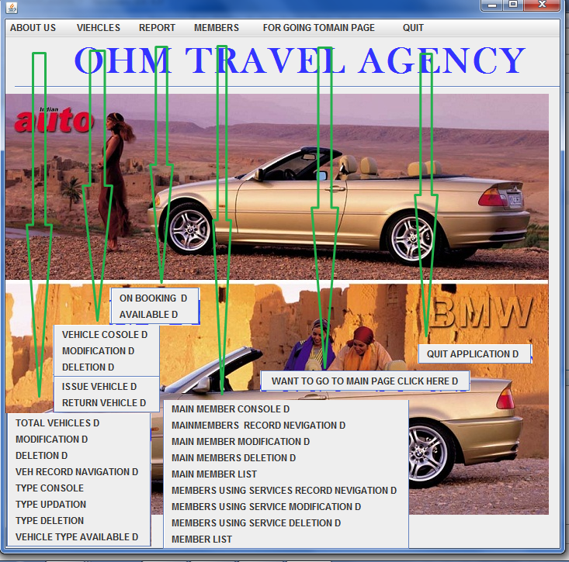

8. References
In order to work on this project titled - travel agency management System, the following books and literature are refered by me during the various phases of development of the project.

(1) The Complete Reference Java 2.0
-by Shildit
- MySQL, Black Book
-by Steven Holzner
(2) Understanding SQL
– Gruber
(3) http://www.mysql.org/

(4) http://www.netbeans.org/

(5) On-line Help of NetBeans ®

(6) Informatics Practices for class XII
-by Sumita Arora
(7) Together with Informatics Practices
(6) Various Websites of Discussion Forum and software development activities.

Other than the above-mentioned books, the suggestions and supervision of my teacher and my class experience also helped me to develop this software project.

